**Day 1 assignment**

1. To list all records with sal > 2000 and comm>200

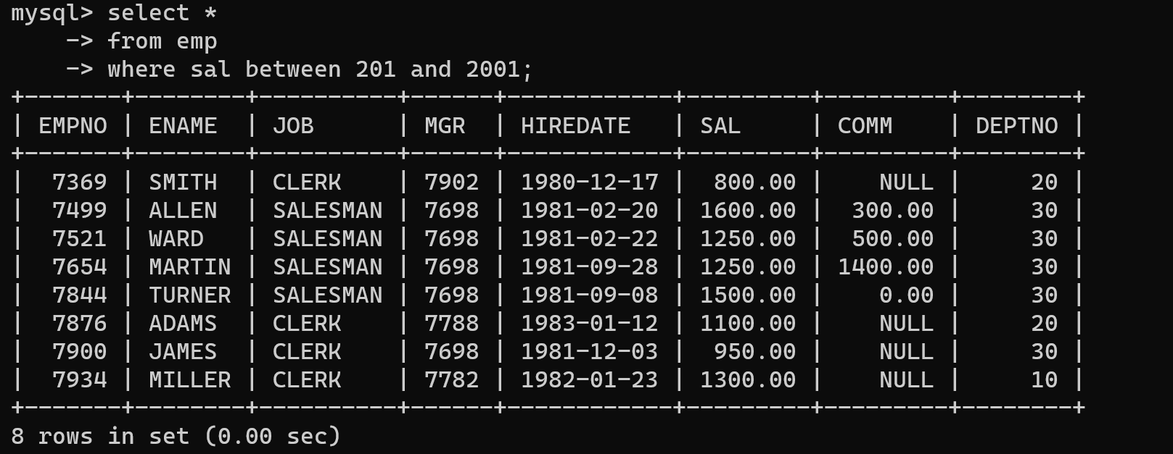

2. To list all record with job=’Clerk’ or sal>2000

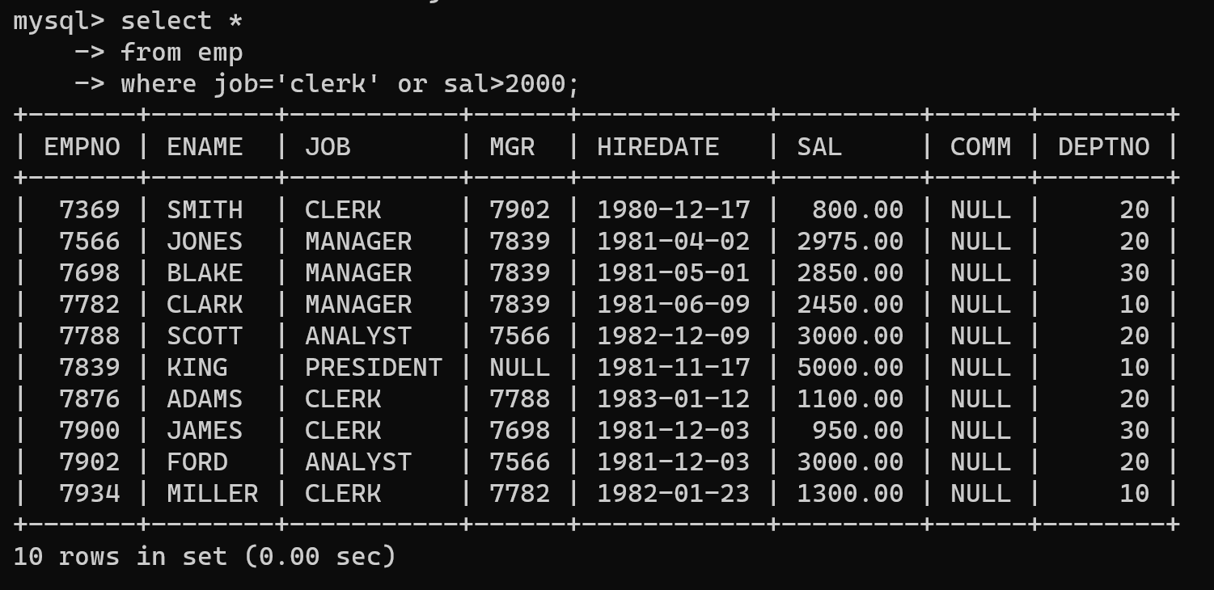

3. To list all the record with sal=1250 or 1100 or 2850

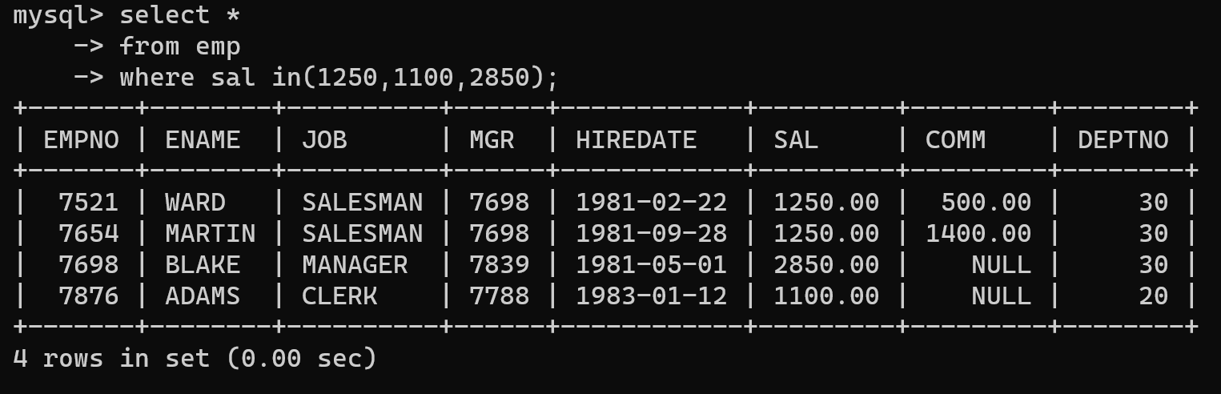

4. To list all employees with sal>1250 and <2850

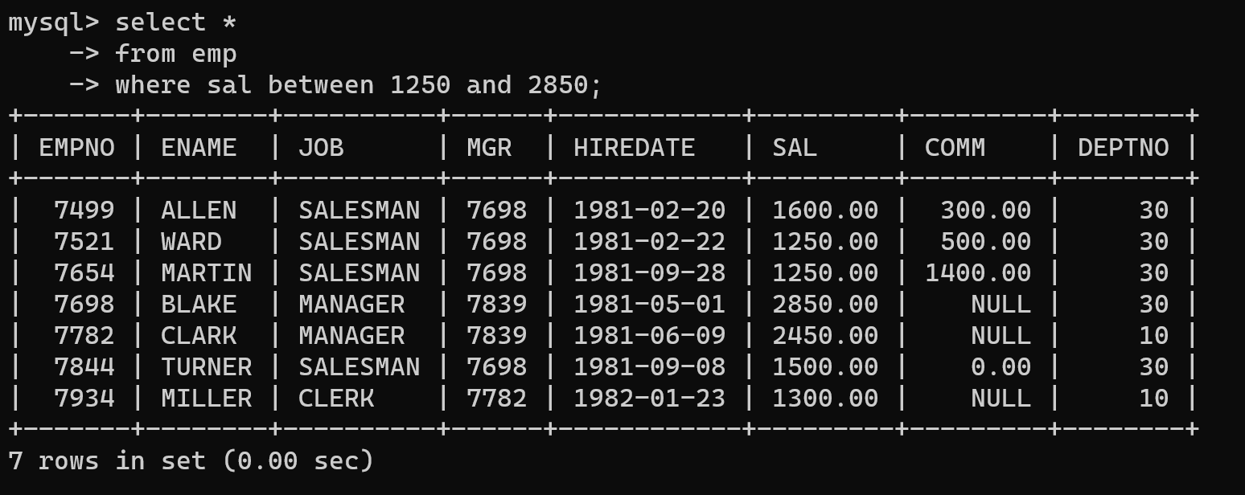

5. To list all employees with name ends with AS

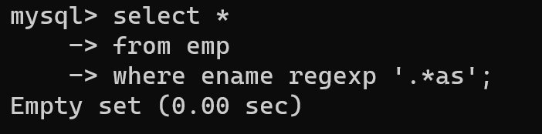

6. To list all employees with job starts with C and ends with K

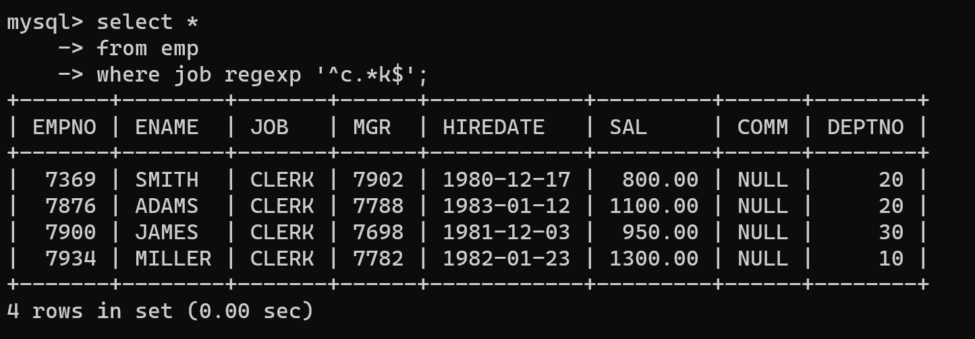

7. To list all employees with job contains L at third position and M at third last position

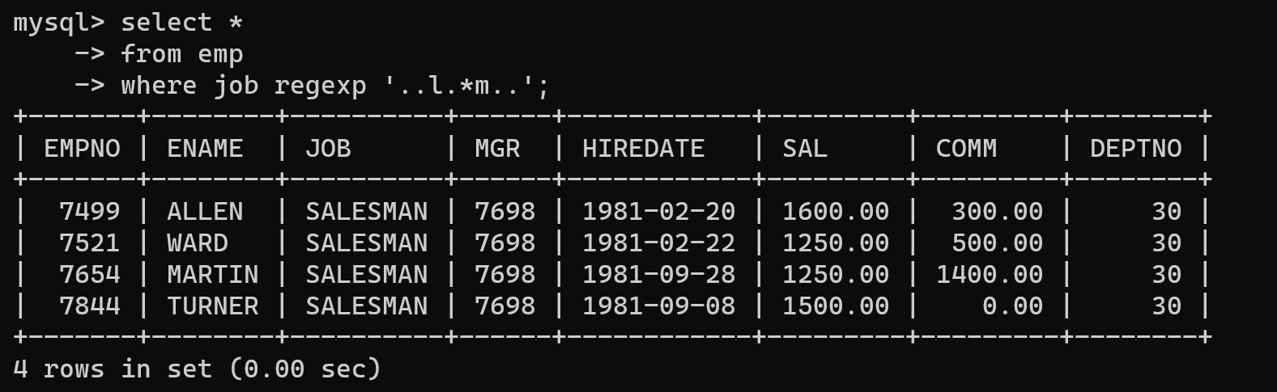

8. To list all the record with sal not equal to 1250 or 1100 or 2850

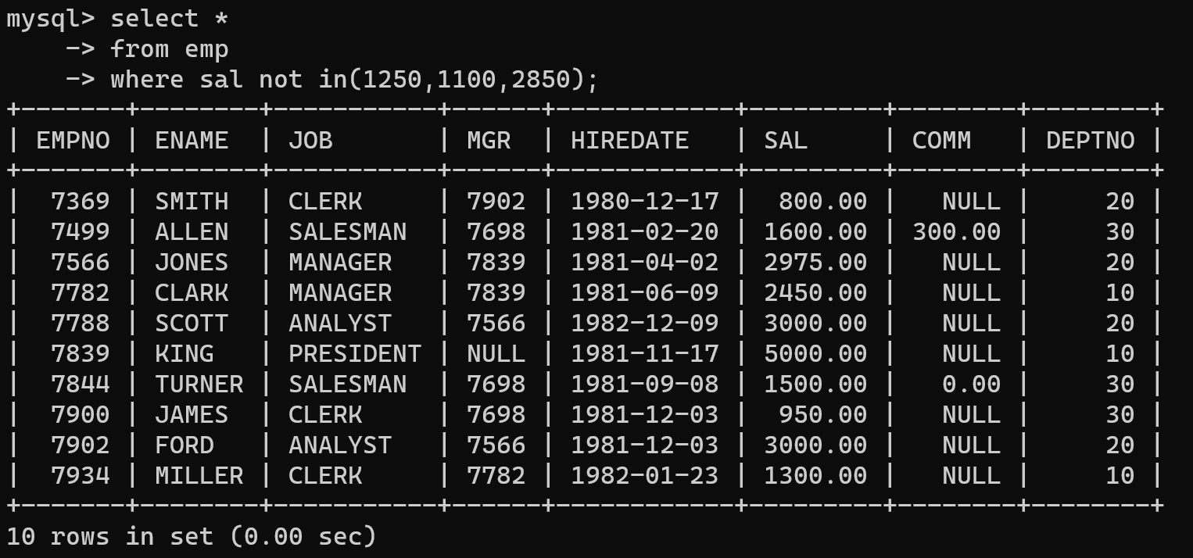

9. To list all employees with sal not >1250 and <2850

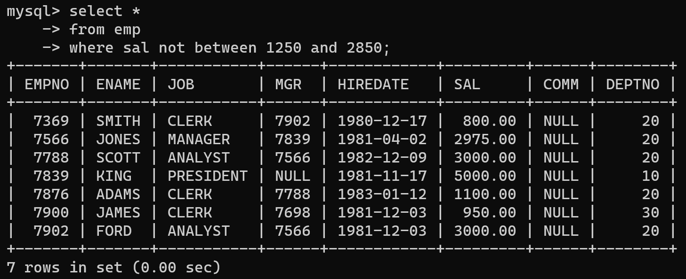

10. To list all employees with job starts with C , E at 3rd position and ends with K

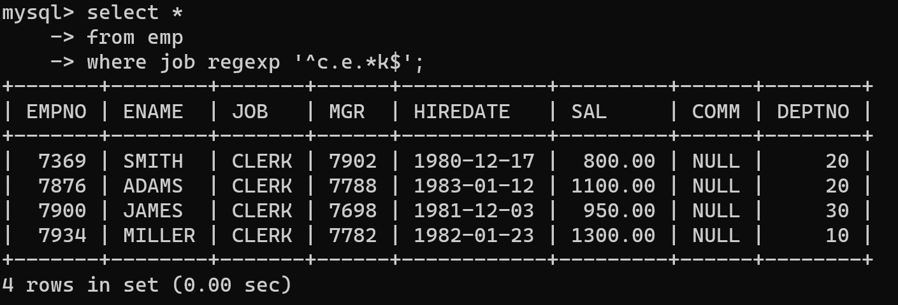

11. To list all rows with comm is null

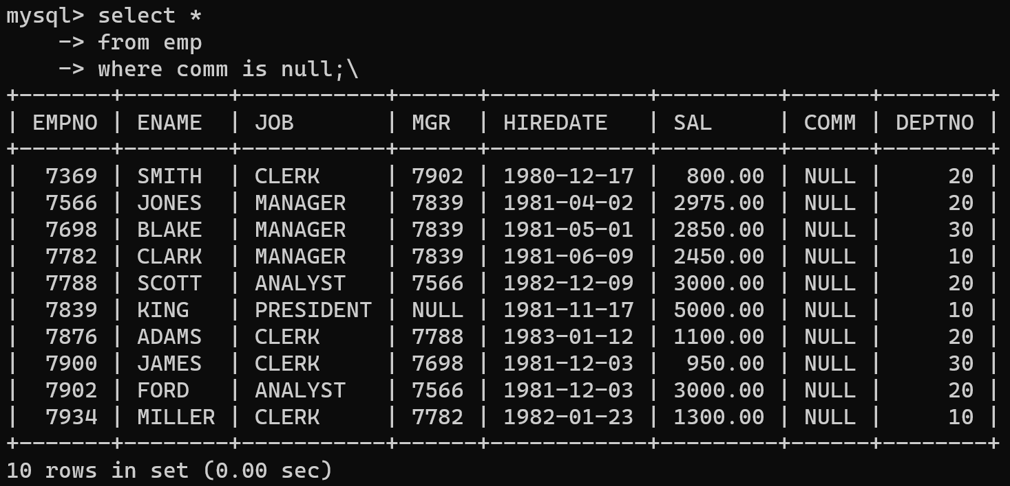

12. To list all employees with sal is null and name starts with ‘S’

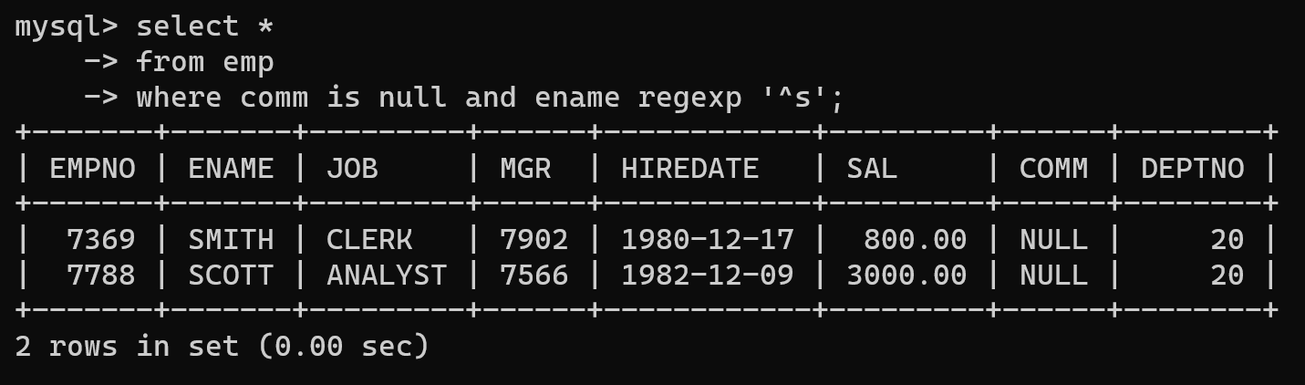

13. To list all employees with job contains 5 characters

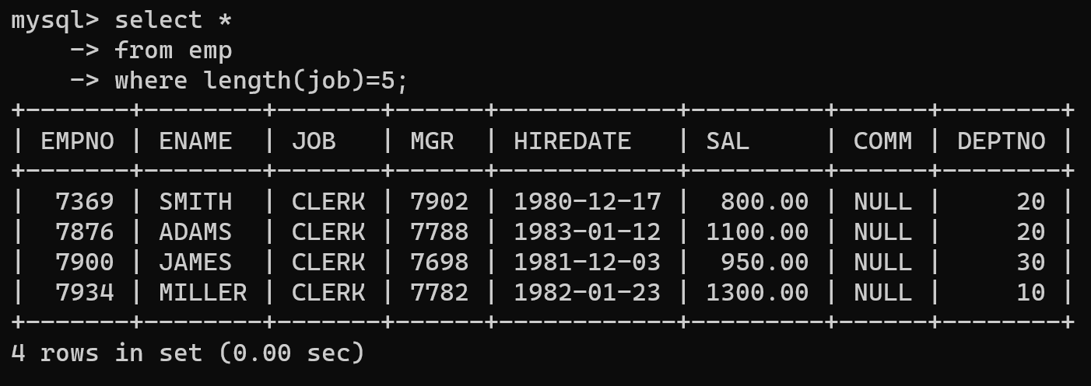

14. To list all employees with name contain ‘A’ at 1 position and job Contains 5 characters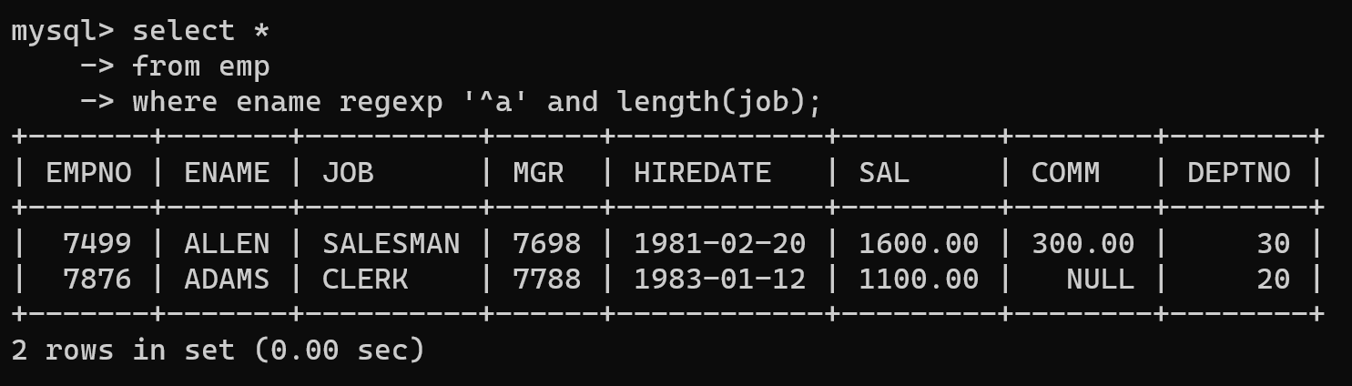

Q2. Solve the following

1. Retrieve the details (Name, Salary and dept no) of the emp who are working in department code 20, 30 and 40.

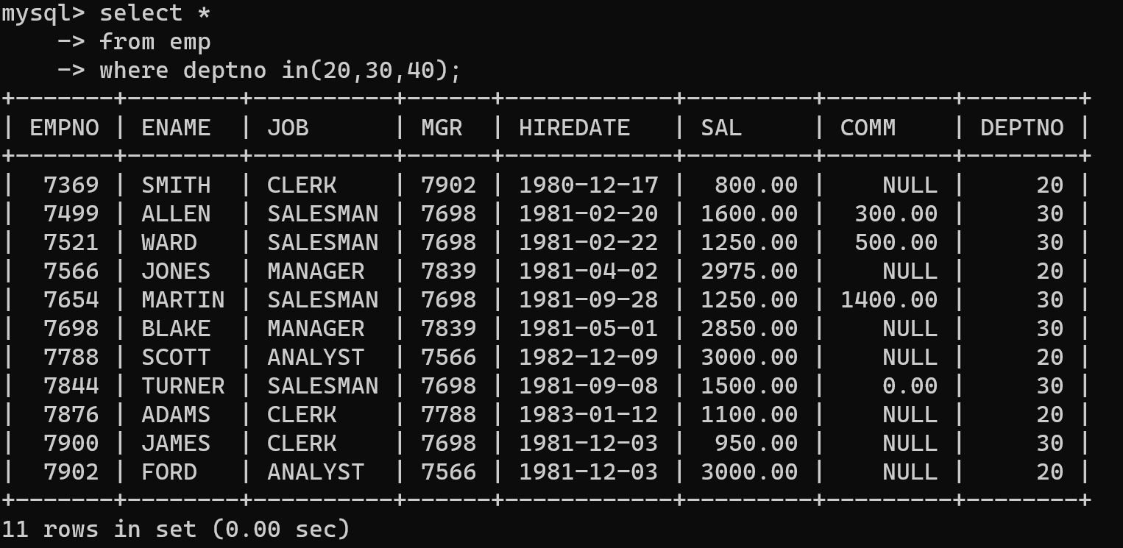

2. Display the total salary of all employees . Total salary will be calculated as sal+comm+sal*0.10

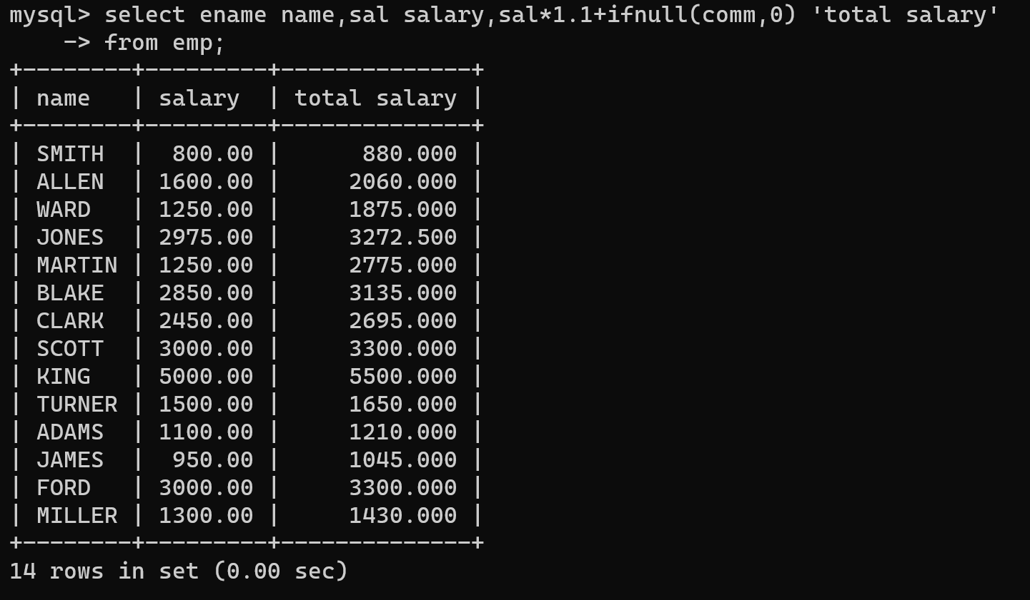

3. List the Name and job of the emp who have joined before 1 jan 1986 and whose

The salary range is between 1200 and 2500. Display the columns with user defined Column Headers.

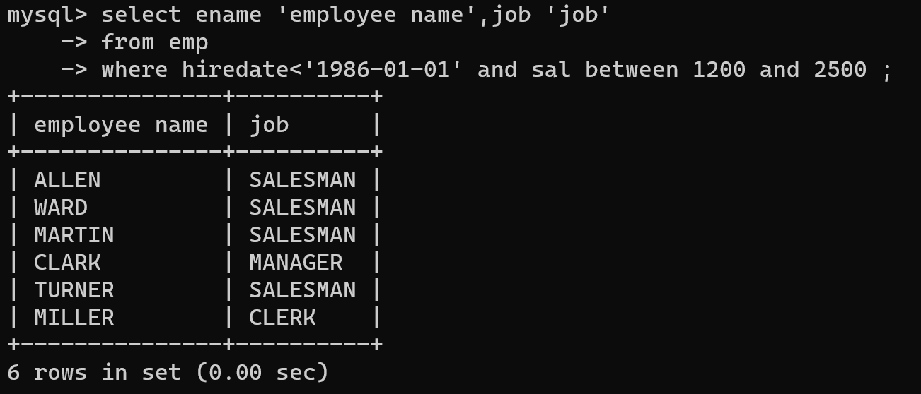

4. List the empno, name, and department number of the emp works under manager

with id 7698

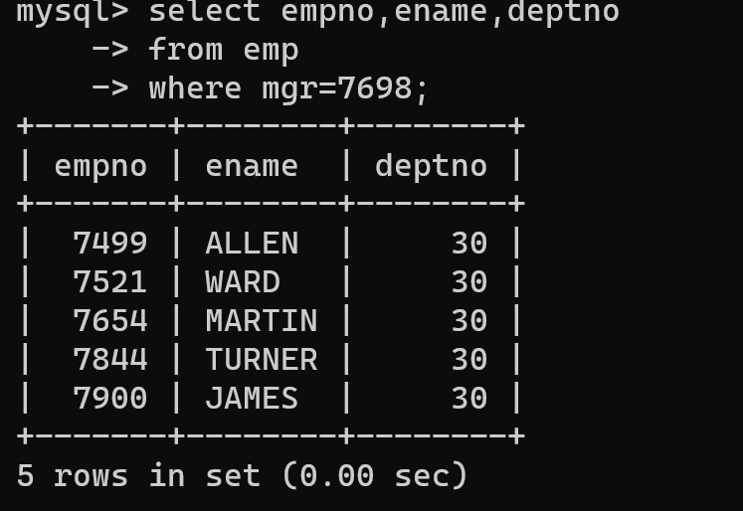

5. List the name, job, and salary of the emp who are working in departments 10 and 30.

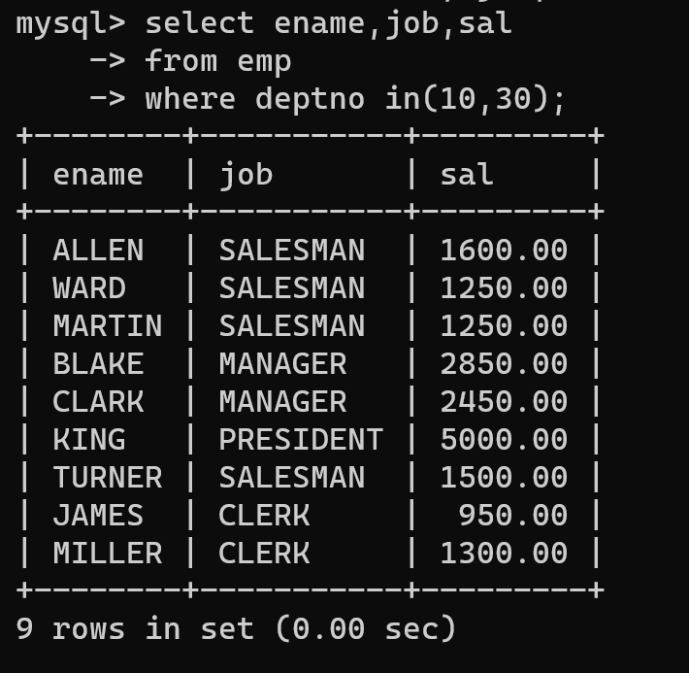

6. Display name concatenated with dept code separated by comma and space. Name

the column as ‘Emp info’.

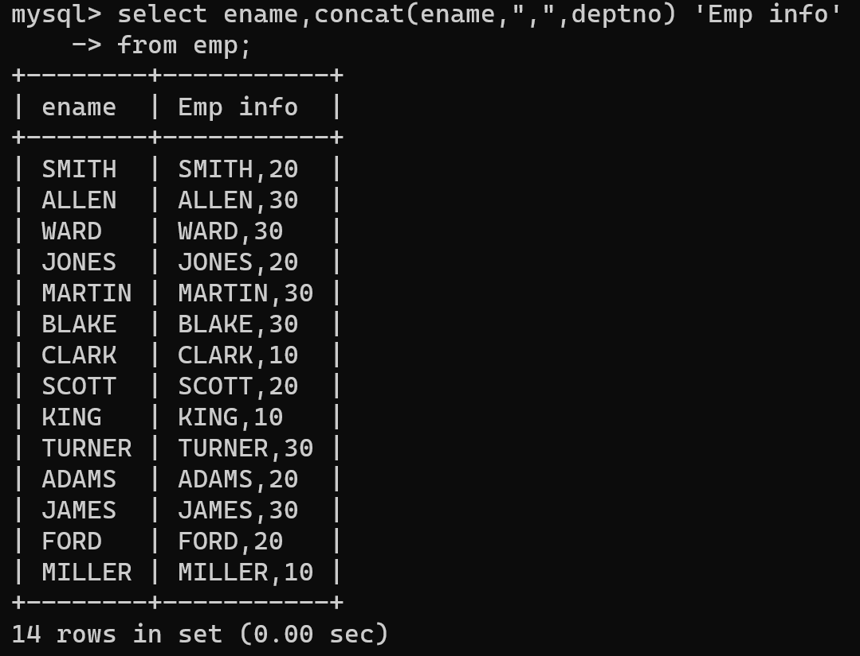

7. Display the emp details who do not have a manager.

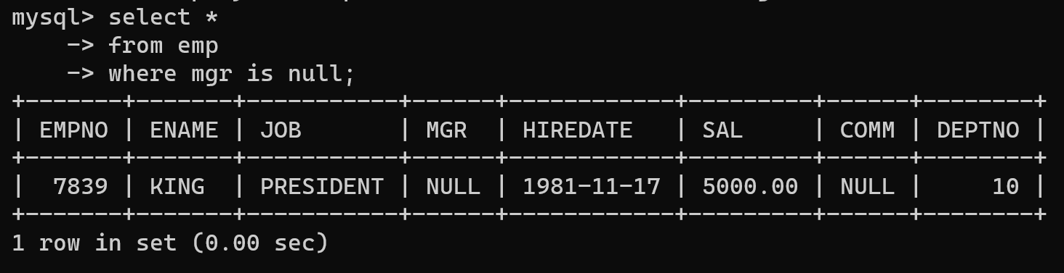

8. Write a query which will display name, department no and date of joining of all

employee who joined January 1, 1981 and March 31, 1983. Sort it based on date of

joining (ascending).

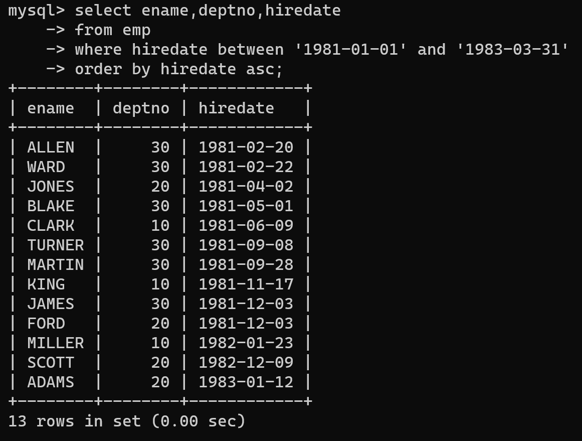

9. Display the employee details where the job contains word ‘AGE’ anywhere in the Job

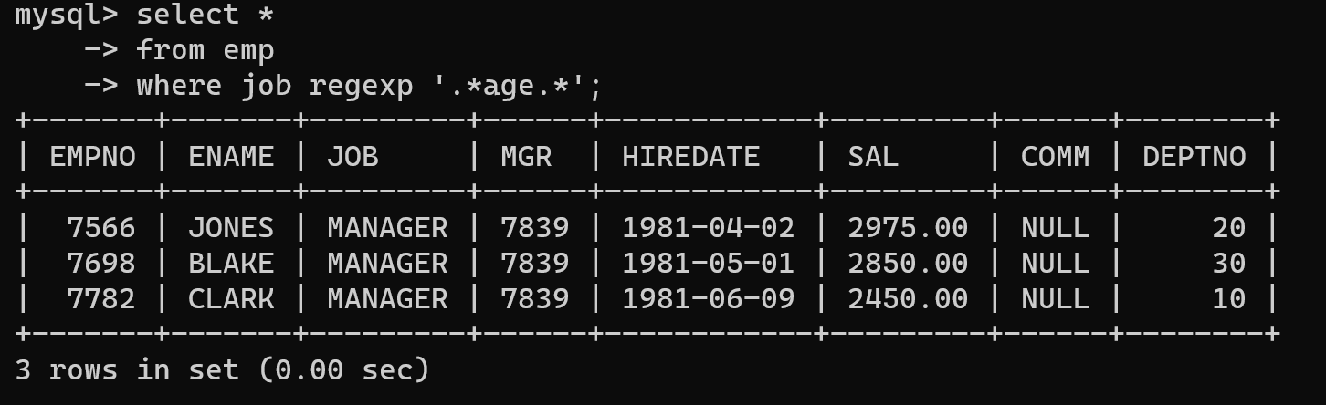

11. List the details of the employee , whose names start with ‘A’ and end with ‘S’ or

whose names contain N as the second or third character, and ending with either ‘N’ or ‘S’.

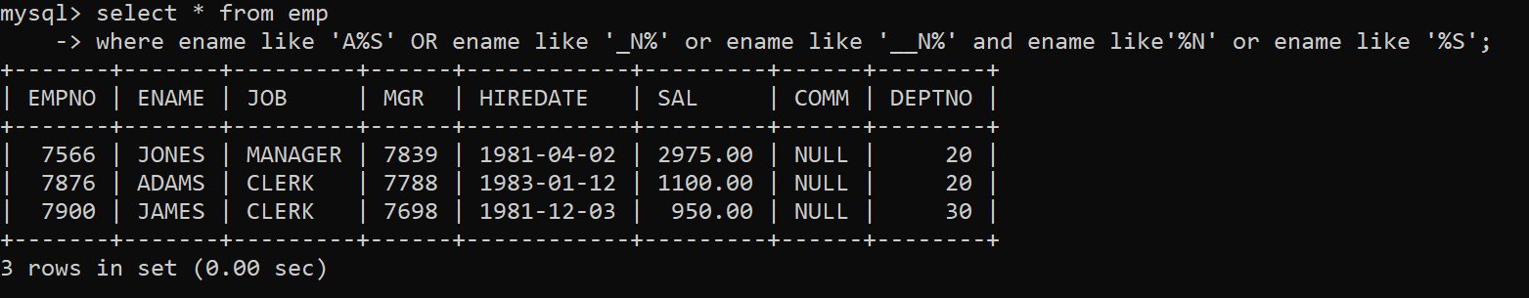

12. List the names of the emp having ‘_’ character in their name.

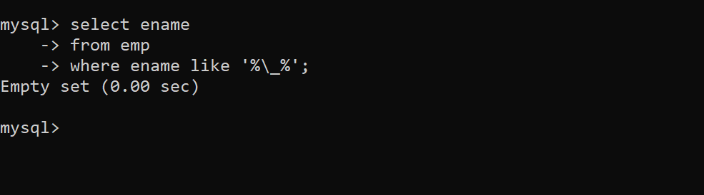

Single Row functions

1. To list all employees and their email, to generate email use 2 to 5 characters from ename

Concat it with 2 to 4 characters in job and then concat it with ‘@mycompany.com’

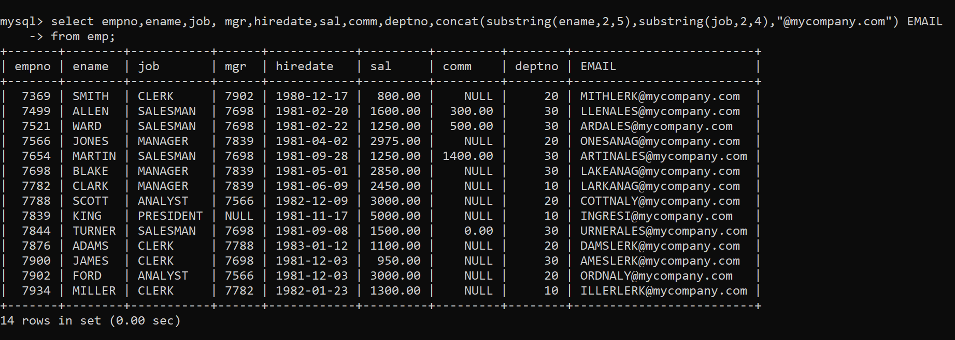

2. List all employees who joined in September.

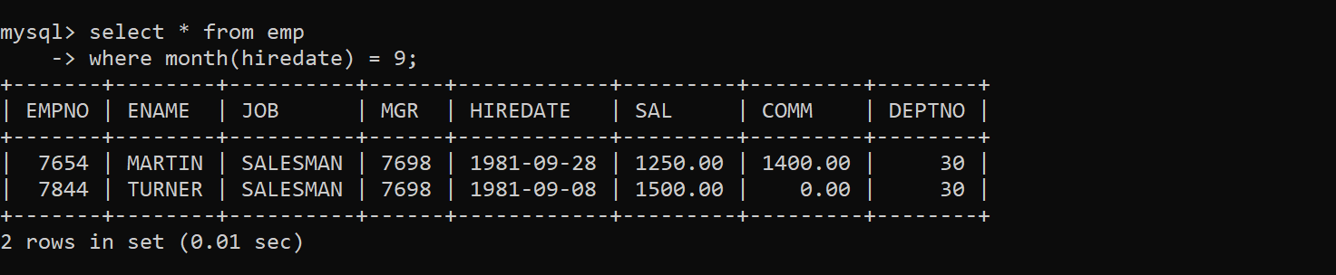

3. List the empno, name, and department number of the emp who have experience of 18 or

more years and sort them based on their experience.

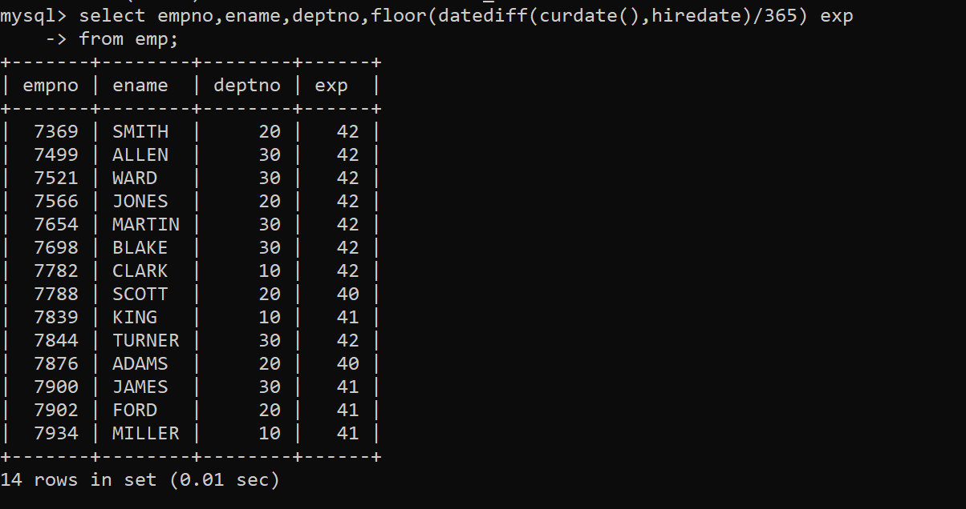

4. Display the employee details who joined on 3rd of any month or any year

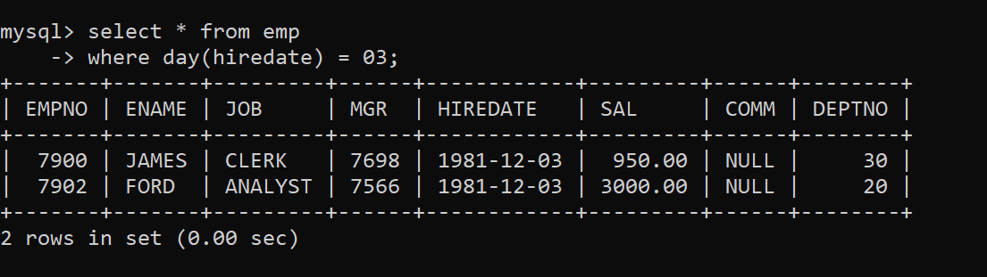

5. display all employees who joined between the years 1981 to 1983.

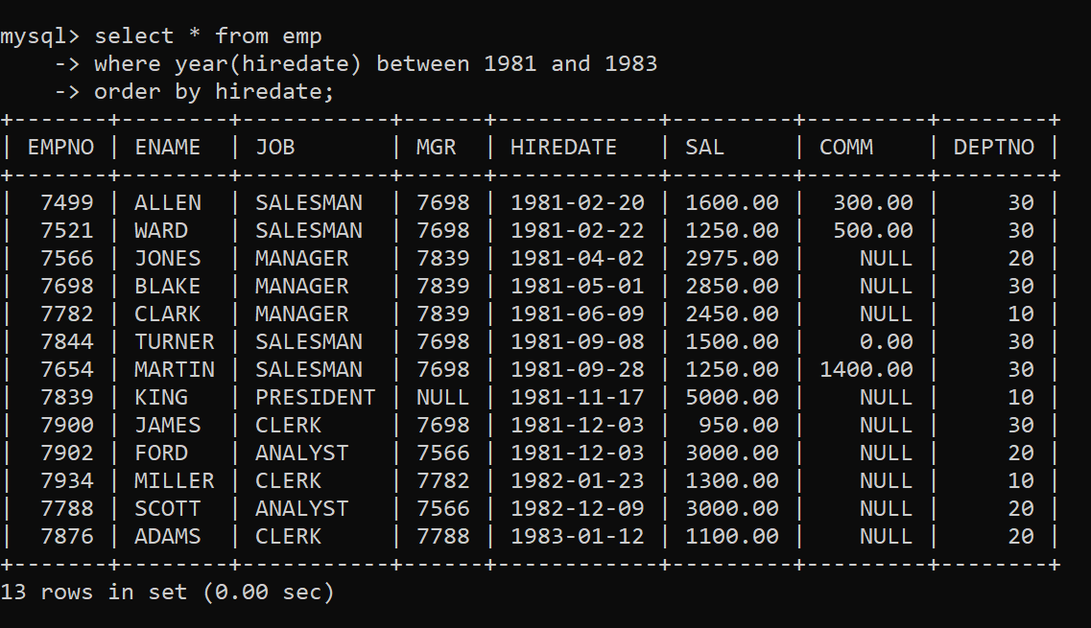

Group functions

6. Display the Highest, Lowest, Total & Average salary of all employees. Label the columns

Maximum, Minimum, Total and Average respectively for each Department. Also round the

result to the nearest whole number.

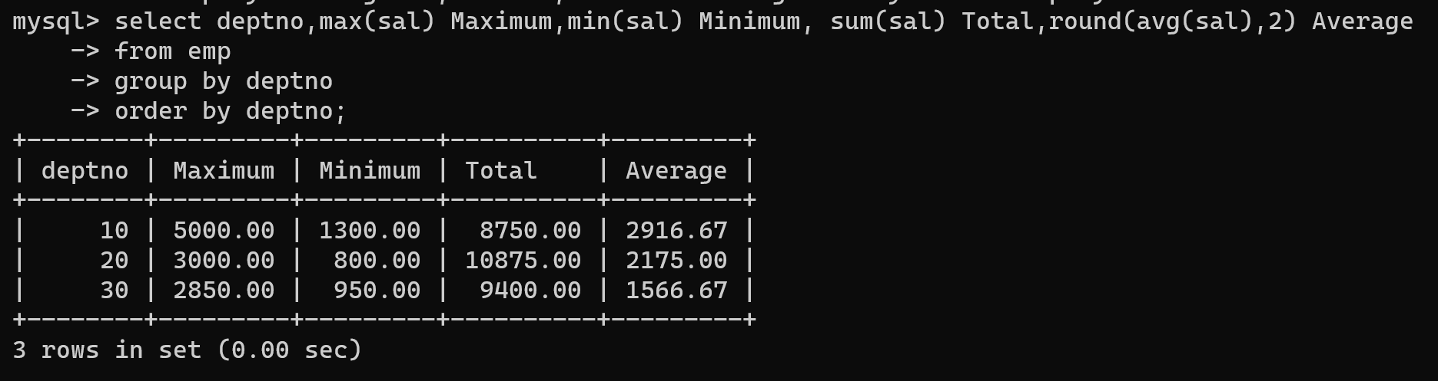

7. Display Department no and number of managers working in that department. Label the

column as ‘Total Number of Managers’ for each department.

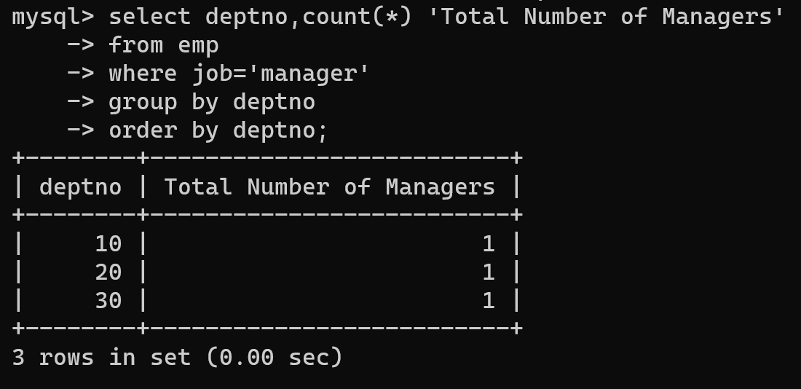

8. Get the Department number, and sum of Salary of all non managers where the sum is greater than 20000.

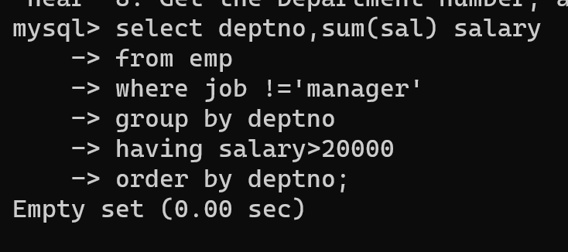

**Day 2: assignment 2**

**All other question solved in day 1**

13. find 3rd highly paid employee

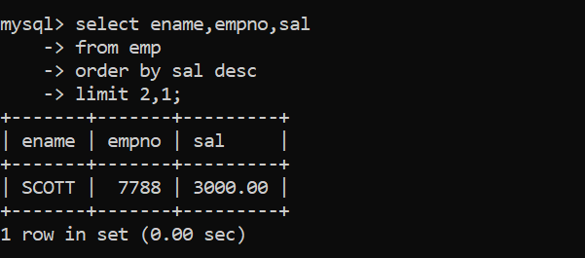

14. find employee who has earned highest commission

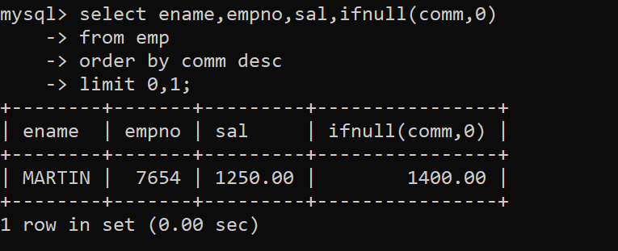

15. display ascii value of 1st character of job from emp

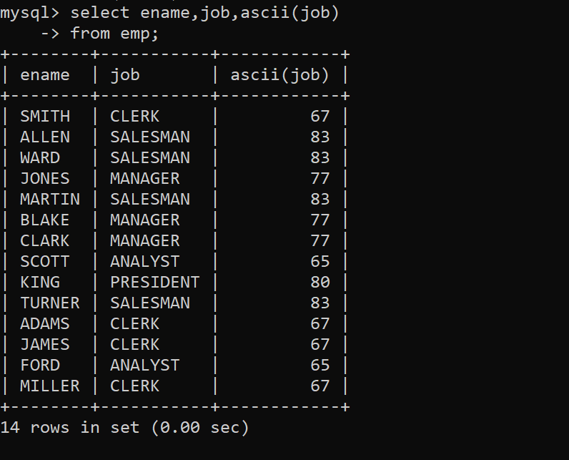

16. display empno,ename,job,code code should be 1 st 3 characters of ename and 1st 3 characters of job.

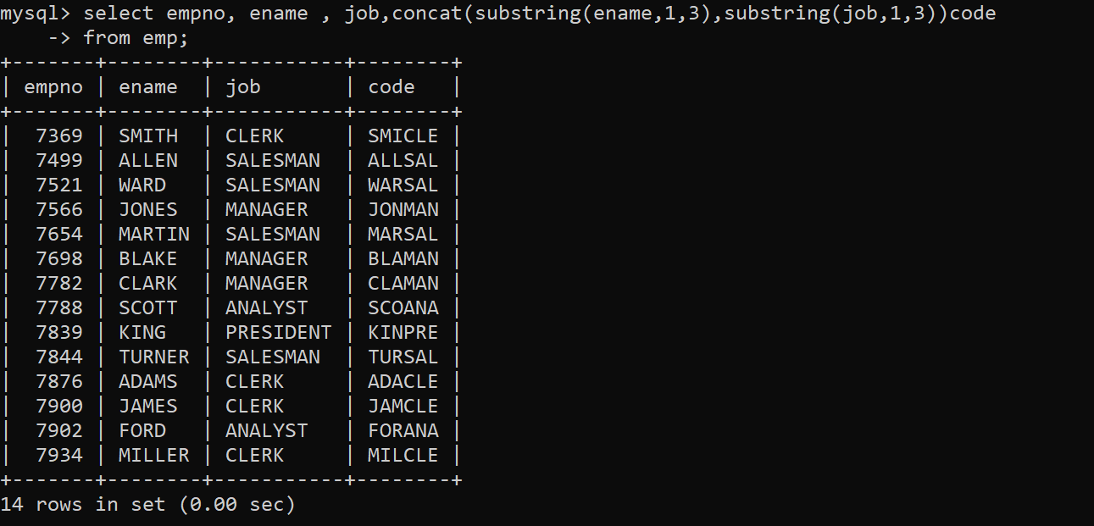

**Day 3:Assignment 3**

Date and Time functions

1. Write a query to display the first day of the month (in datetime format) three months before the current month.

Sample current date : 2014-09-03

Expected result : 2014-06-01

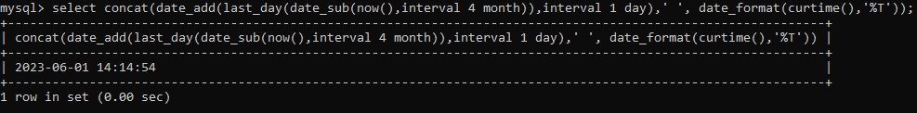

2. Write a query to display the last day of the month (in datetime format) three months before the current month.

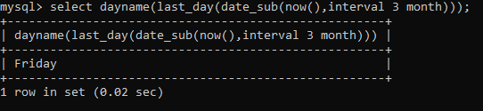

3. Write a query to get the distinct Mondays from hiredate in emp tables.

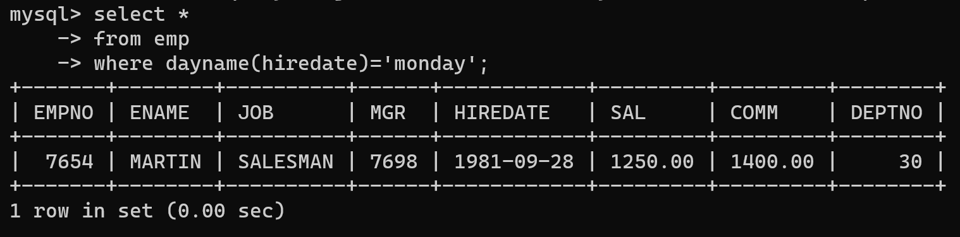

4. Write a query to get the first day of the current year.

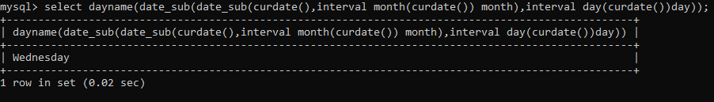

5. Write a query to get the last day of the current year.

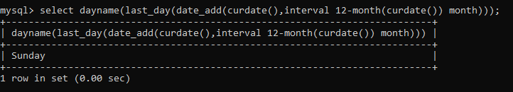

6. Write a query to calculate your age in year.

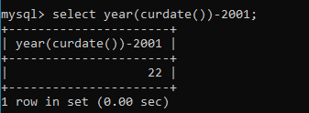

7. Write a query to get the current date in the following format.

Sample date : 04-sep-2014

Output : September 4, 2014

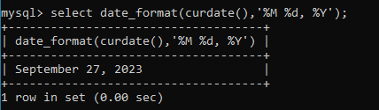

8. Write a query to get the current date in Thursday September 2014 format.

Thursday September 2014

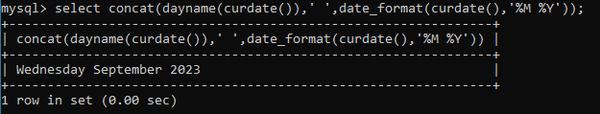

9. Write a query to extract the year from the current date.

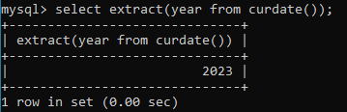

10. Write a query to get the first name and hire date from employees table where hire date between '1987-06-01' and '1987-07-30'

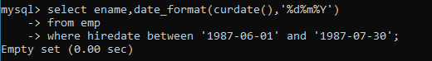

11. Write a query to display the current date in the following format.

Sample output: Thursday 4th September 2014 00:00:00

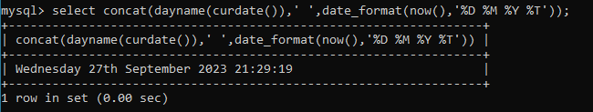

12. Write a query to display the current date in the following format.

Sample output: 05/09/2014

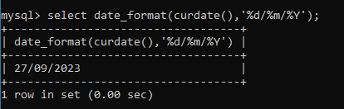

13. Write a query to display the current date in the following format.

Sample output: 12:00 AM Sep 5, 2014

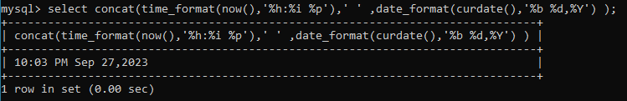

14. Write a query to get the employees who joined in the month of June.

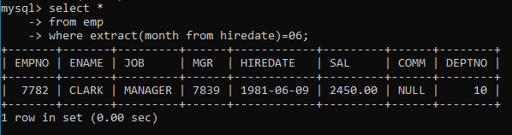

15. Write a query to get the years in which more than 10 employees joined.

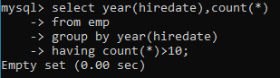

But count(*)>=10;

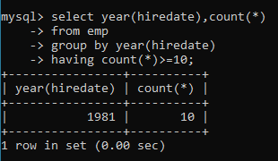

16. Write a query to get first name of employees who joined in 1987.

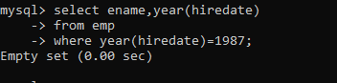

But for 1881;

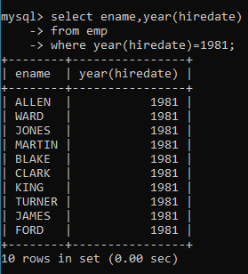

17. Write a query to get employees whose experience is more than 5 years.

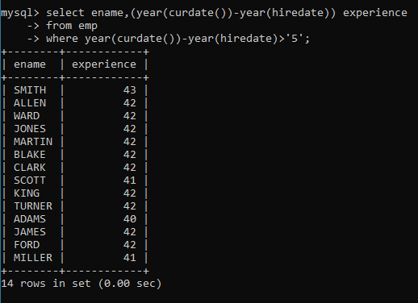

18. Write a query to get employee ID, first name, and date of first salary of the Employees.

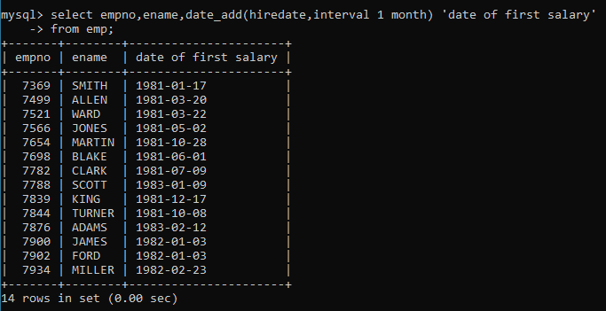

19. Write a query to get first name, hire date and experience of the Employees. Sample table: employees

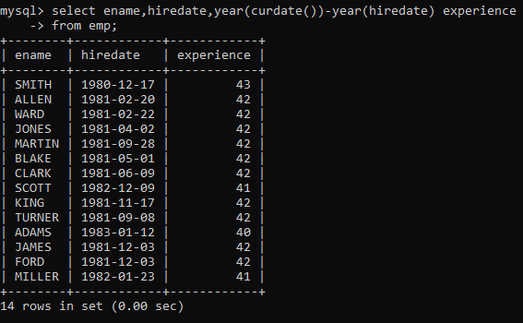

20. Write a query to get the department ID, year, and number of employees Joined.

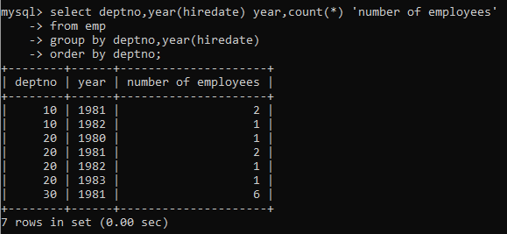

**Assignment 1:**

Write SQL statement for the following

1. To find all managers with salary >1500

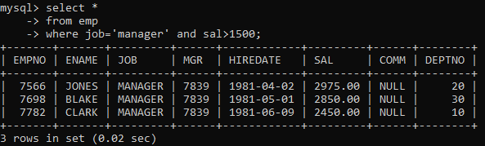

2. list all employees with sal >1200 and < 2000

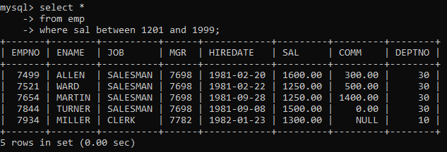

2. list all employees with sal is 1600 or sal is 800 or sal is 1900

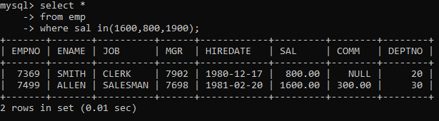

4. list all employees with R at second last position in name

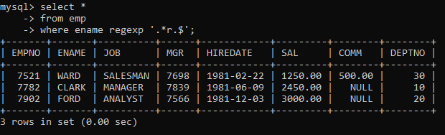

5. List all employees with name starts with A and ends with N

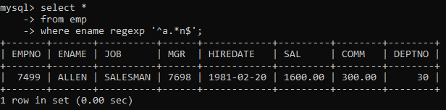

Q2. Solve following

1. list all employees with salary > 1250 and dept no=30

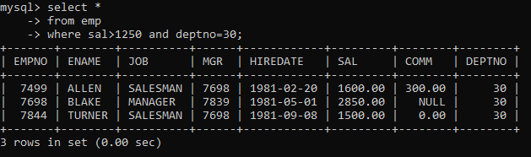

2. list all employees with salary >=1250 and <= 3000

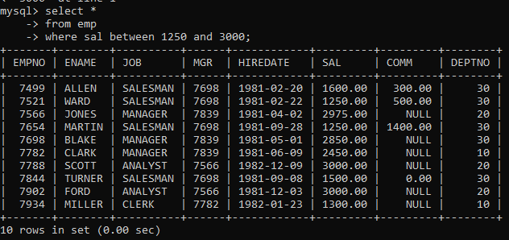

3. list all employees with salary >1250 and < 3000

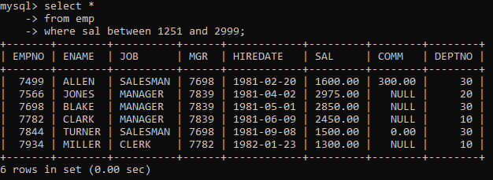

4. list all employees with salary either equal to 3000 or 1250 or 2500

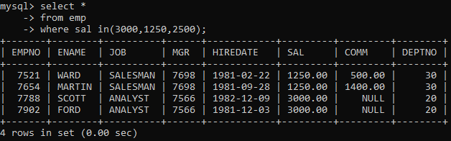

5. list all employee with name=SMITH

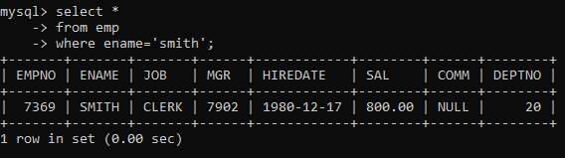

6. list all employees with name starting with S

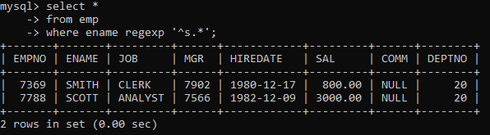

7. list all employees with name ending with S

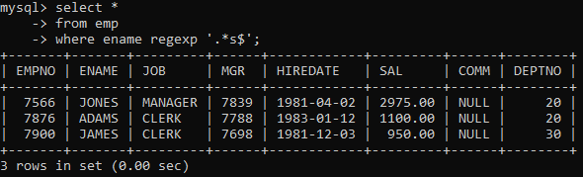

8. list all employees with name contains I at 2nd position

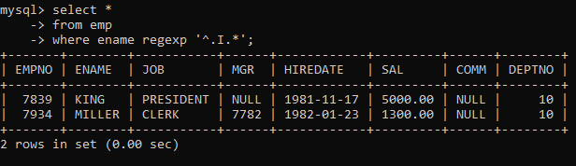

9. list all employees with name starts with A ends witn N and somewhere in between L is there

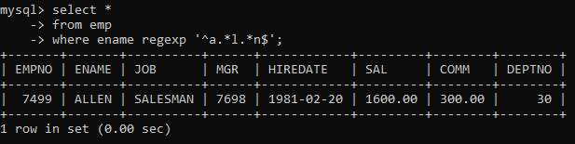

10. list all employees with name starts with A and B at 3 rd position and P at second last position

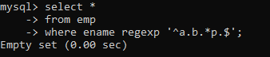

11. List all employees with name starts with either A or starts with S or starts with W

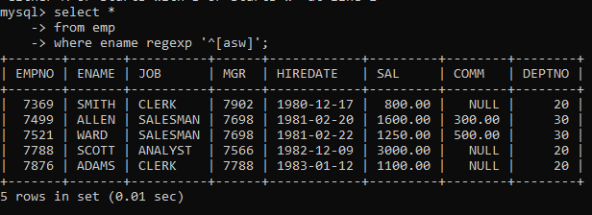

12. find max sal and min sal for each job

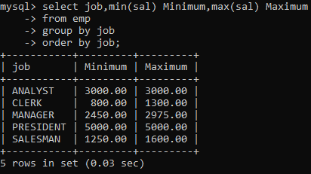

13. find how many employees have not received commission

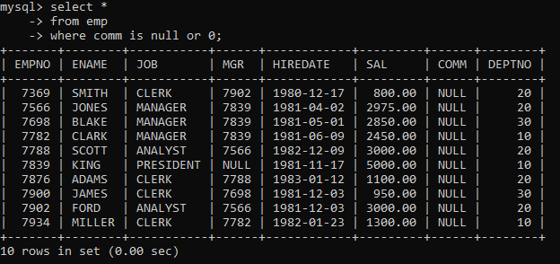

14. find sum of sal of all employees working in dept no 10

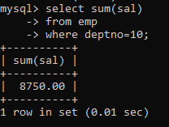

15. find maximum salary,average sal for each job in every department

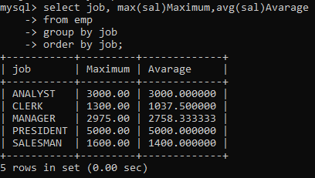

16. find max salary for every department if deptno is > 15 and arrange data in deptno order.

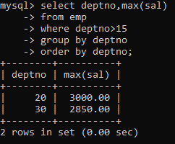

17. find sum salary for every department if sum is > 3000

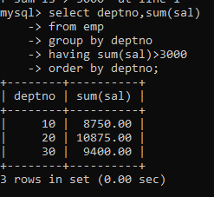

18. list all department which has minimum 5 employees

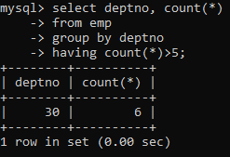

19. count how many employees earn salary more than 2000 in each job

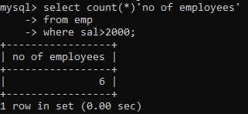

20. list all enames and jobs in small case letter

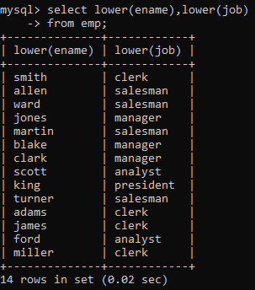

21. list all names and jobs so that the length of name should be 15 if it is samller then add

spaces to left

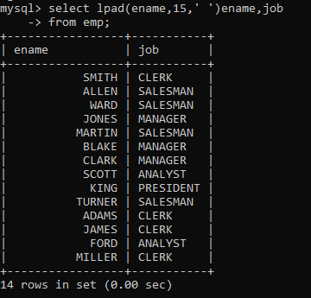

22. display min sal,max sal, average sal for all employees working under same manager

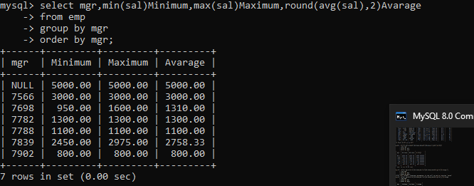

23. find sum of total earnings(sal+comm), average of sal+comm for all employees who earn sal >2000 and work in either dept no 10 or 20

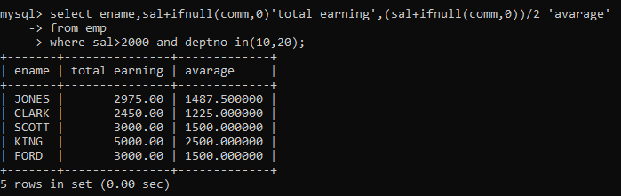

24. list all employees who joined in Aug 1980 and salary is >1500 and < 2500



25. list all employees joined in either aug or may or dec

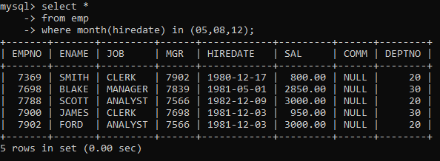

26. display name and hiredate in dd/mm/yy format for all employees whose job is clerk and

they earn some commission

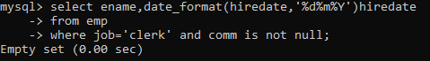

27. list empcode,empno,name and job for each employee. (note :empcode is 3 to 5 characters

from name and last 2 characters of job)

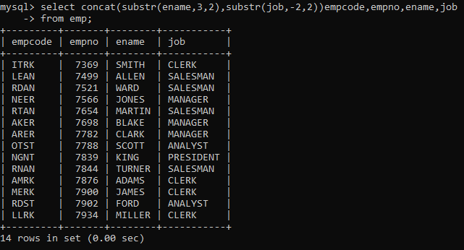

28. display thousand separator and $ symbol for commission if it is null then display it as 0 for all

employees whose name starts with A and ends with N

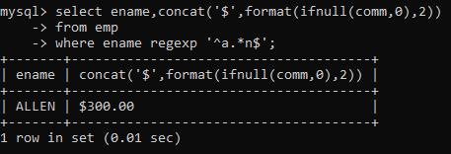

29. Display empid,name,sal,comm,remark Remark should base on following conditions

comm >= 600 "excellent Keep it up"

if it < 600 or not null "good"

Otherwise "Need improvement"

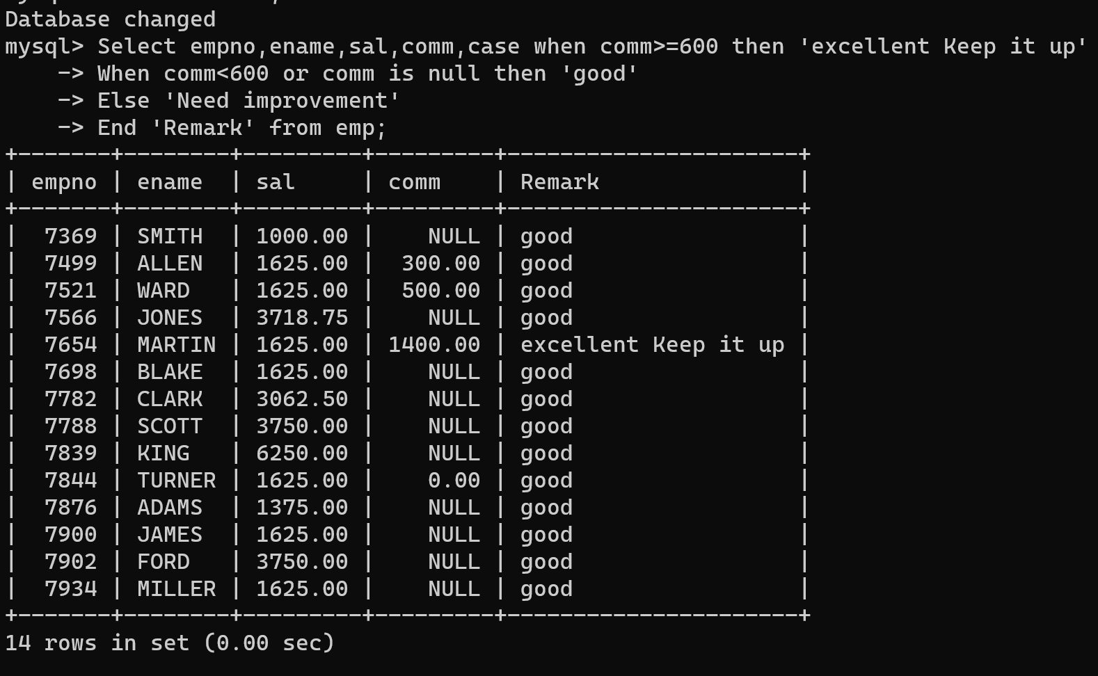

30. Display empid, name, deptno and department name by using following conditions.

dept 10 then "Hr"

if 20 then "Admin"

if 30 then "accounts"

otherwise purchase

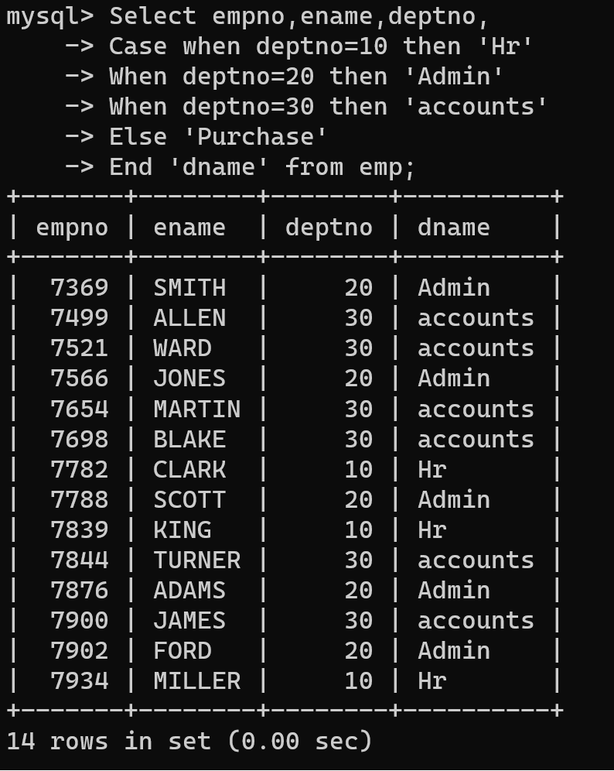

31. Practice creating following tables

create table mydept_DBDA(

deptid number primary key,

dname varchar2(20) not null unique,

dloc varchar2(20)

)

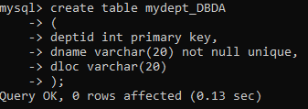

insert into mydept_DBDA values(30,'Purchase','Mumbai');



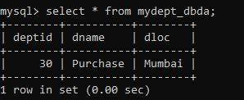

create table myemployee(

empno number(5) primary key,

fname varchar2(15) not null,

mname varchar2(15),

lname varchar2(15) not null,

sal number(9,2) check(sal >=1000),

doj date default sysdate,

passportnum varchar2(15) unique,

deptno number

constraint fk_deptid references mydept_DBDA(deptid)

on delete cascade

)

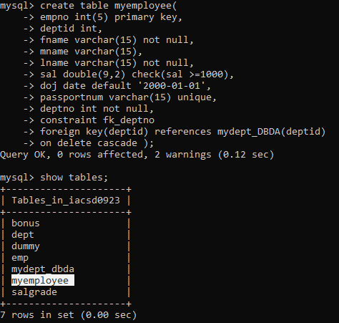

32. Create following tables Student, Course

Student (sid,sname) ---------------- sid ---primary key

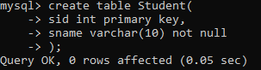

Course(cid,cname)-------------- cid ---primary key

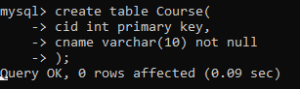

Marks(studid,coursed,marks)

create table marks(

studid number,

courseid number,

marks number,

constraint pk primary key(studid,courseid),

constraint fk_sid foreign key (studid) references student(sid) on delete set null,

constraint fk_cid foreign key (courseid) references course(cid)

)

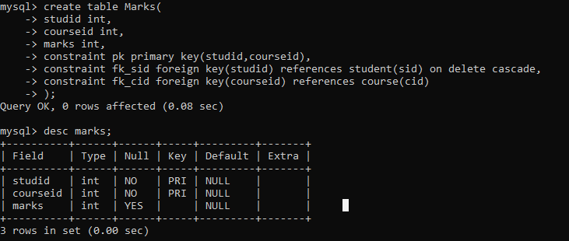

Sample data for marks table

studid,courseid,marks

1 1 99

1 3 98

2 1 95

2 2 97

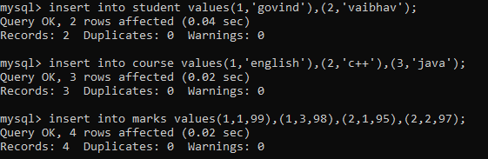

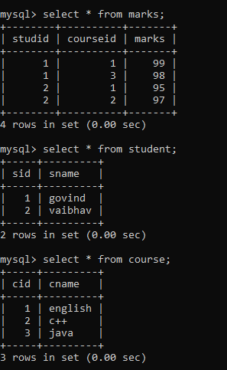

33. Create empty table emp10 with table structure same as emp table.

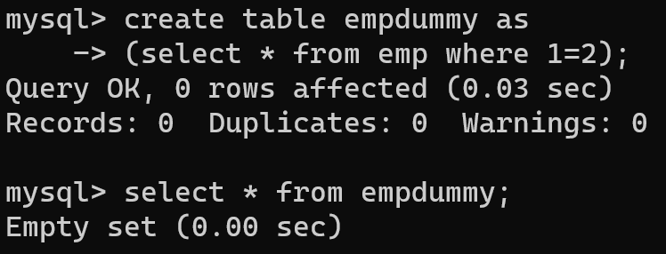

34. Solve following using alter table

add primary key constraint on emp,dept,salgrade

emp ---- empno

dept--- deptno

salgrade--- grade

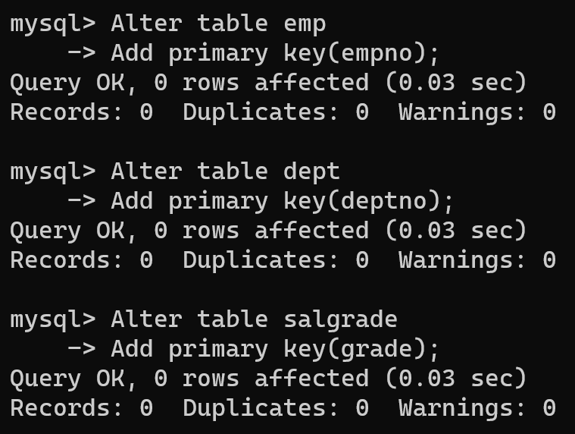

add foreign key constarint in emp

deptno --->> dept(deptno)

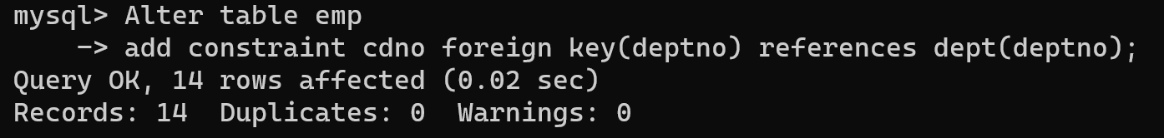

add new column in emp table netsal with constraint default 1000

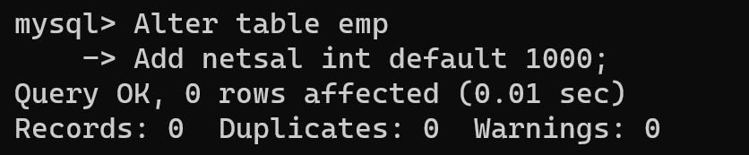

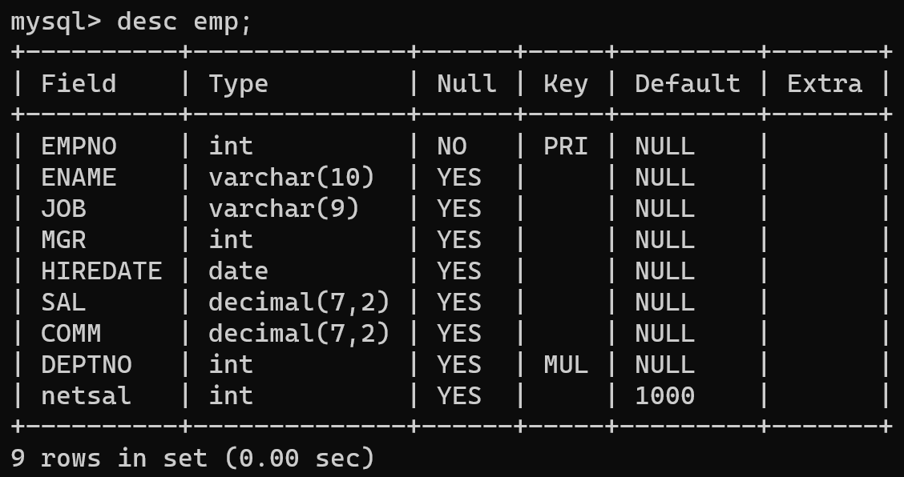

35. Update employee sal ---- increase sal of each employee by 15 % sal +comm, change the job to manager and mgr to 7777 for all employees in deptno 10.

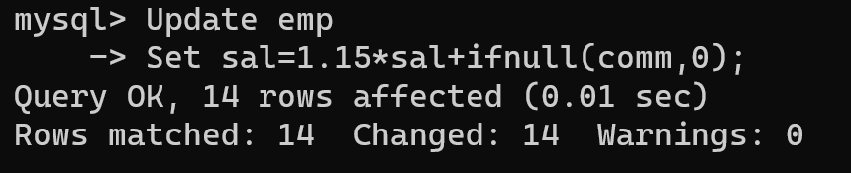

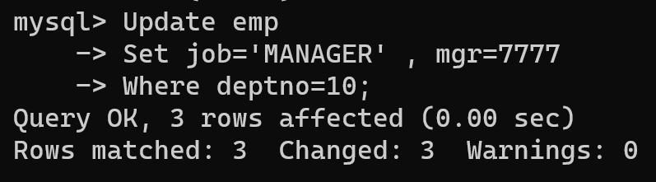

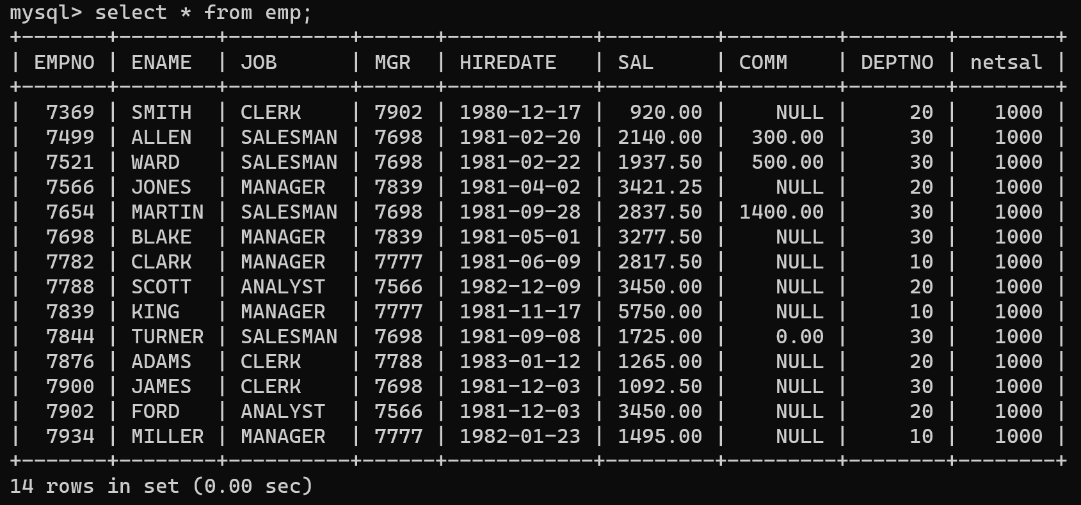

36. change job of smith to senior clerk

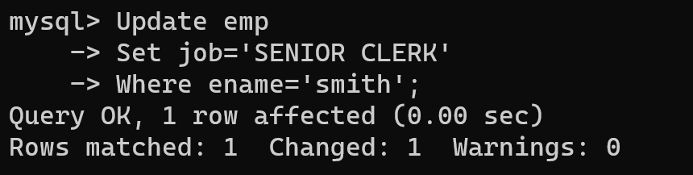

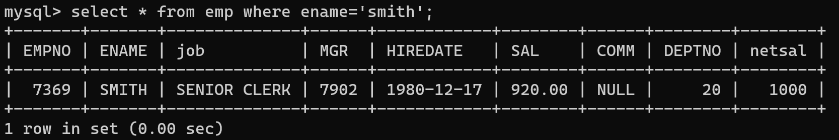

37. increase salary of all employees by 15% if they are earning some commission

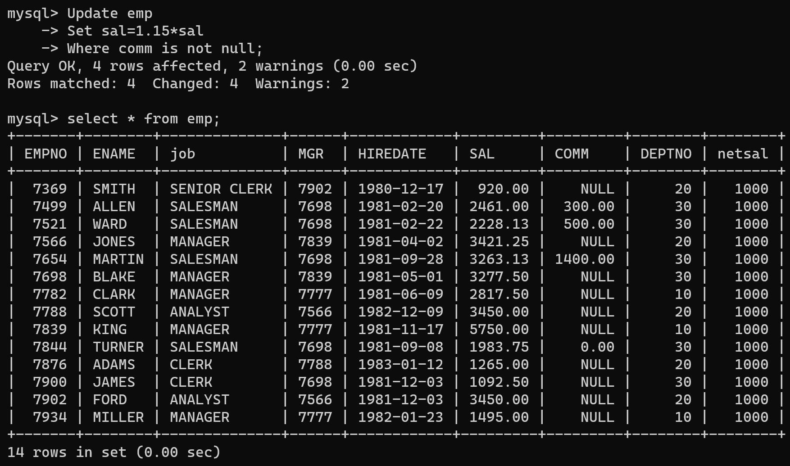

38. list all employees with sal>smith's sal

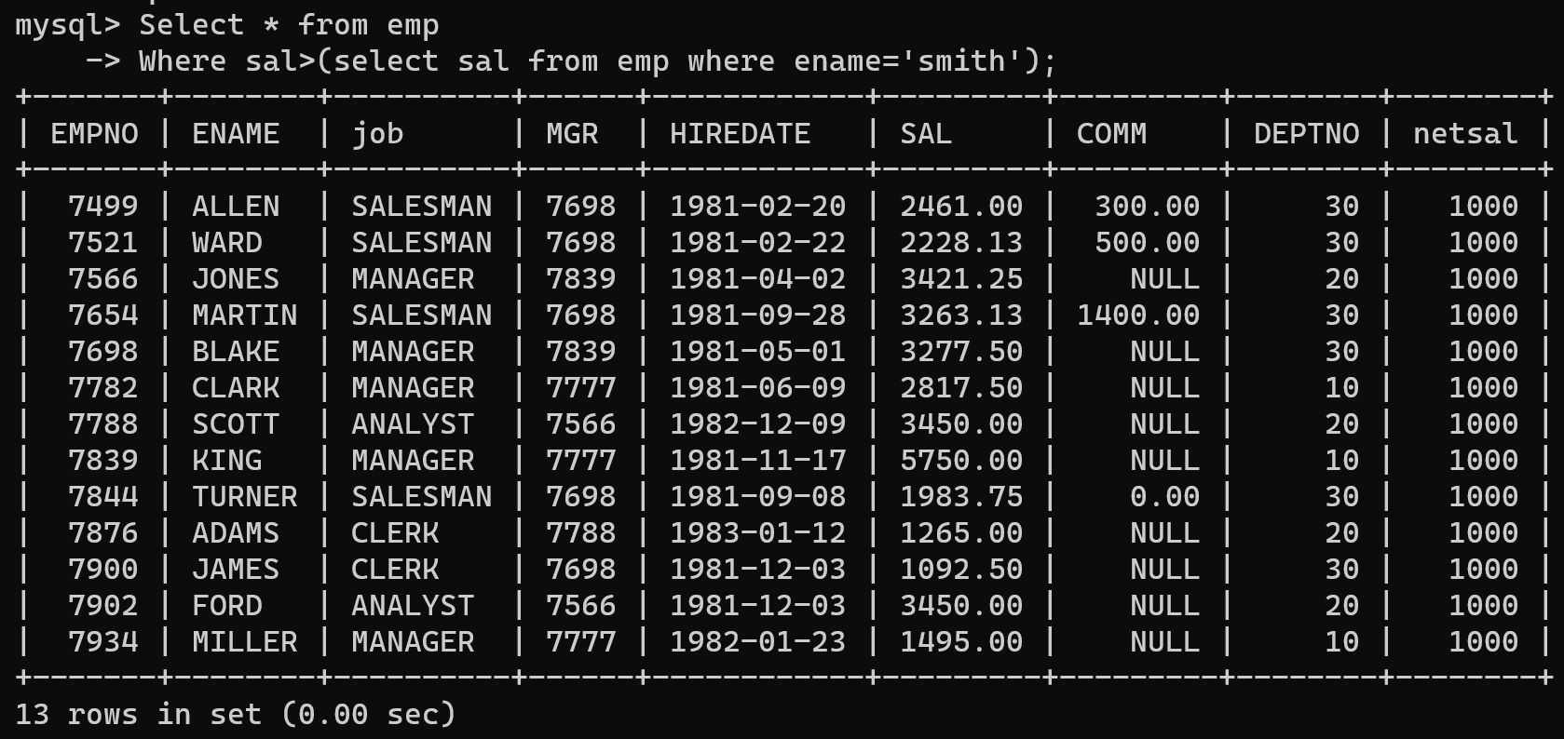

39. list all employees who are working in smith's department

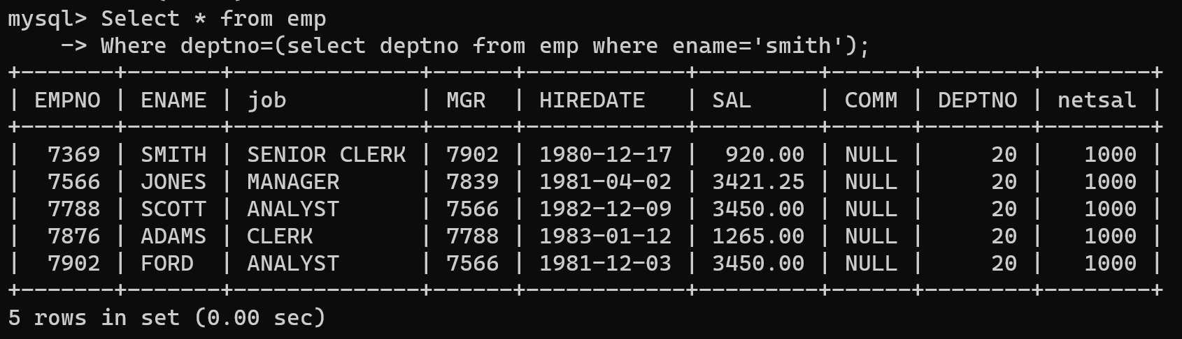

40. list all employees with sal < rajan's sal and salary > revati's sal

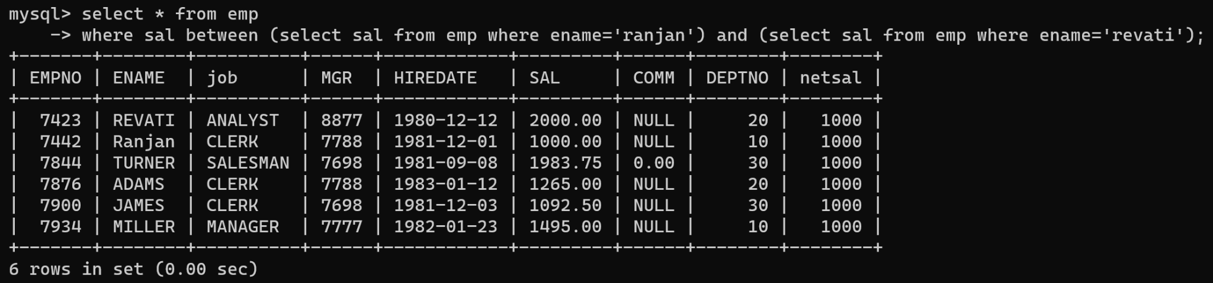

41. delete all employees working in allen department



42. change salary of Alan to the salary to Miller.



43. change the salary of all employees who working in Ward's department to the salary of Miller.



44. list all employees with salary > either Smith's salary or alan's sal

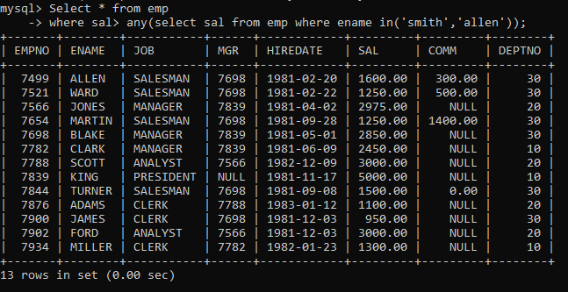

45. list all employees who earn more than average sal of dept 10

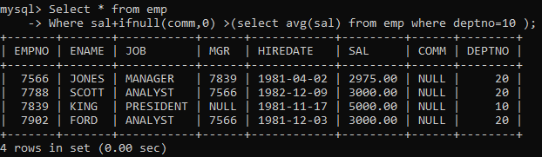

46. list all employees who earn more than average sal of Alan's department

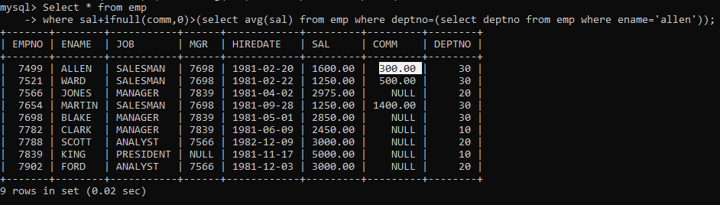

47. list all employees who are working in purchase department

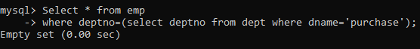

48. list all employees who earn more than average salary of their own department

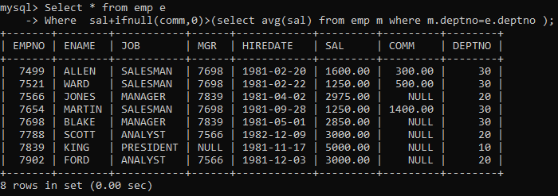

49. list all employees who earn sal < than their managers salary

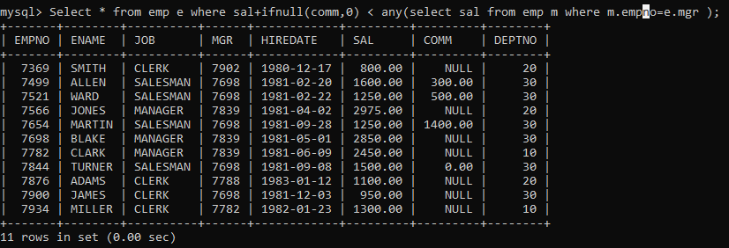

50. list all employees who are earning more than average salary of their job

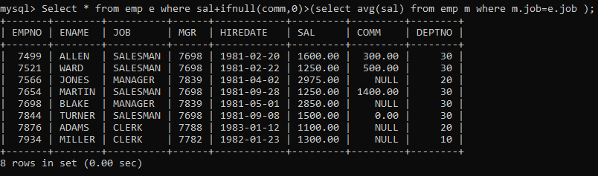

51. display employee name and department

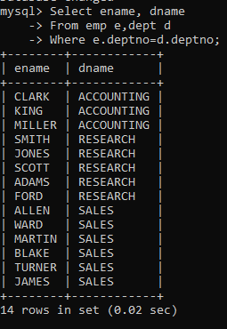

52. display empno,name,department name and grade (use emp,dept and salgrade table)

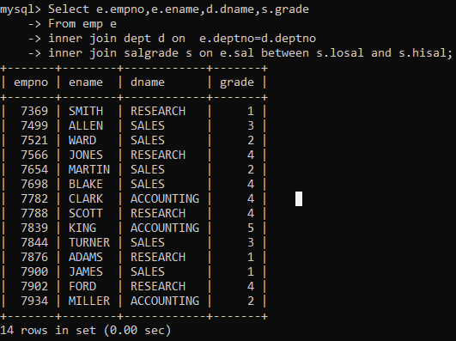

53. list all employees number,name, mgrno and manager name

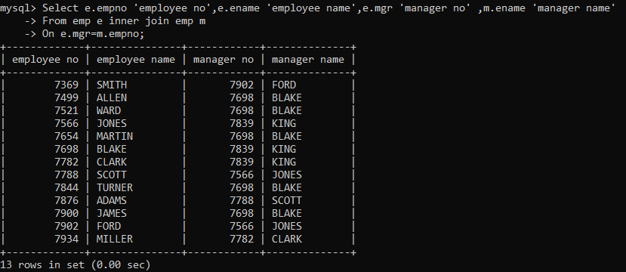

54. create following tables and solve following questions(primary keys are marked in yellow)

foreign keys are marked in green

product(pid,pname,price,qty,cid,sid)

salesman (sid,sname,address)

category(cid,cnam,description)

1. list all product name,their category name and name of a person, who sold that product



2. list all product name and salesman name for all salesman who stays in pune



3. list all product name and category name



55. create following tables and solve following questions(primary keys are marked in yellow) foreign keys are marked in green

faculty(fid,fname,sp.skill1,sp.skill2)

courses(cid,cname,rid,fid)

room(roomid,rname,rloc)

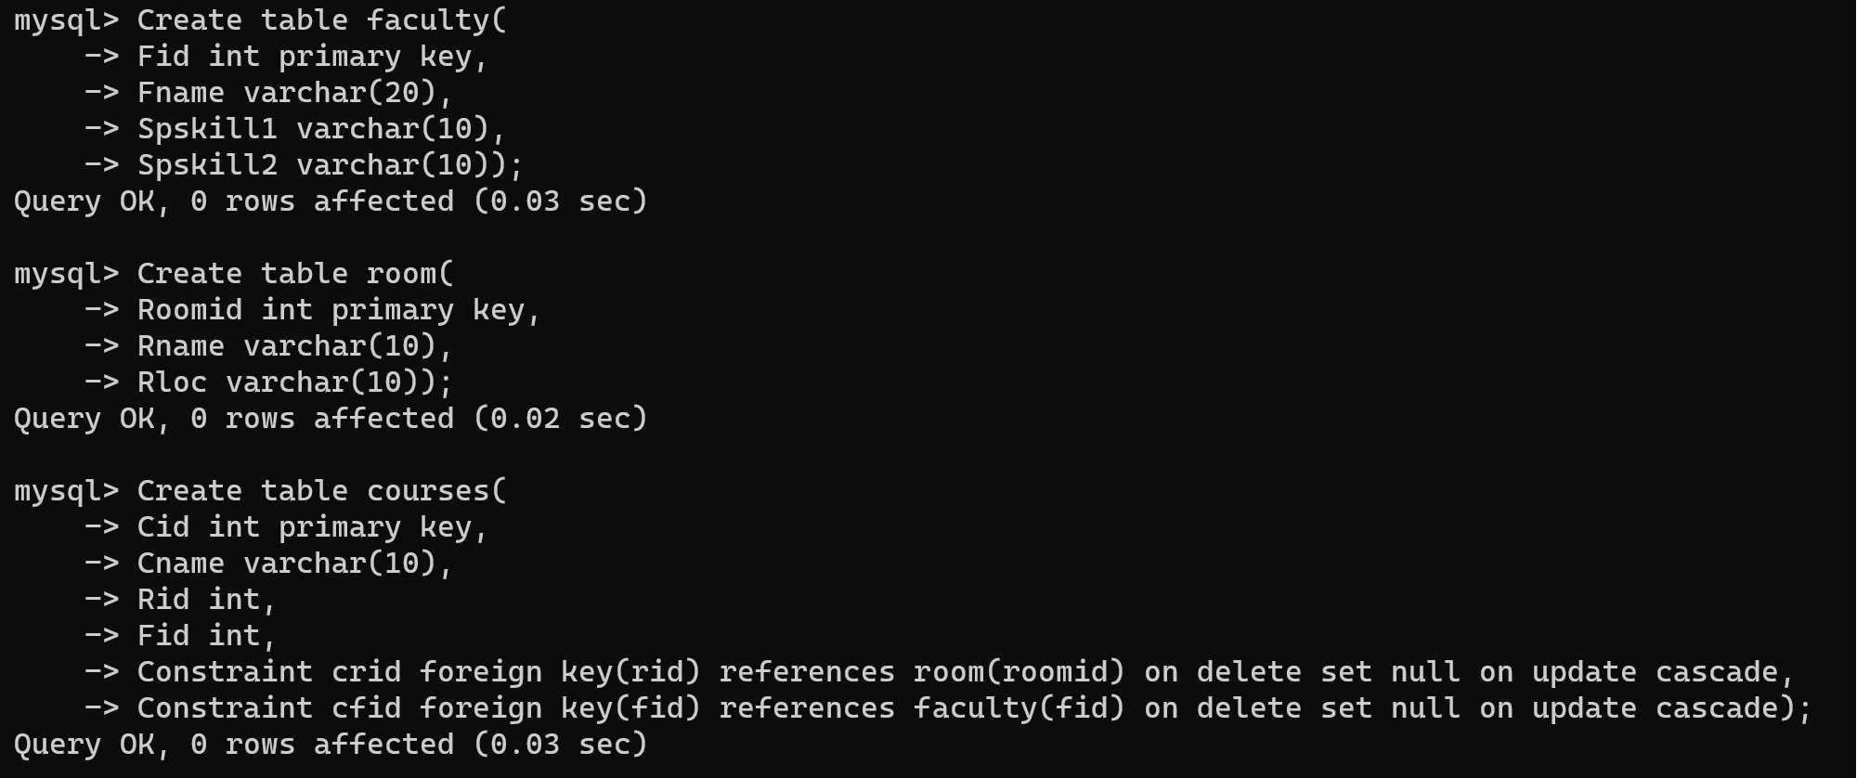

faculty

fid fname spskill1 spskill2

10 kjzhcjhz a b

11 sdd x z

12 lksjk a x

13 ksdjlkj a b



courses

cid cname rid fid

121 DBDA 100 10

131 DAC 101

141 DTISS

151 DIOT 105 12



Room

roomid rname rloc

100 jasmin 1st floor

101 Rose 2nd floor

105 Lotus 1st floor

103 Mogra 1st floor



1. list all courses for which no room is assigned and all rooms for which are available

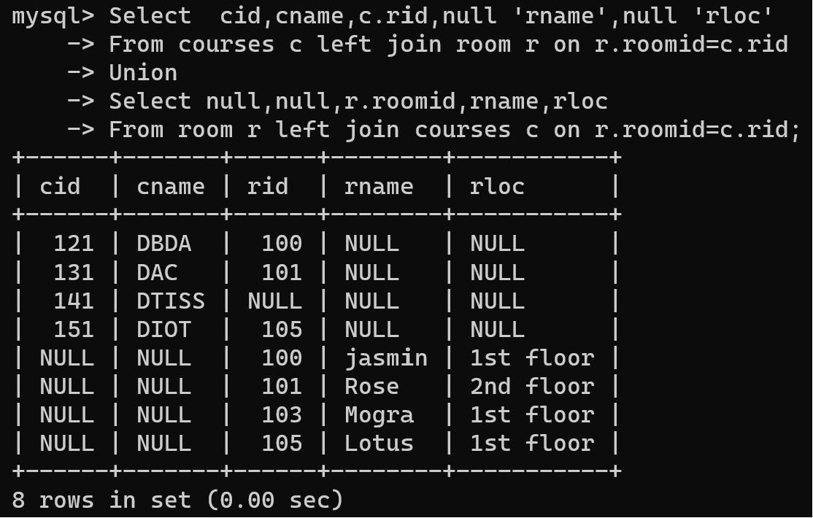

2. list all faculties who are not allocated to any course and rooms which are not allocated to any course

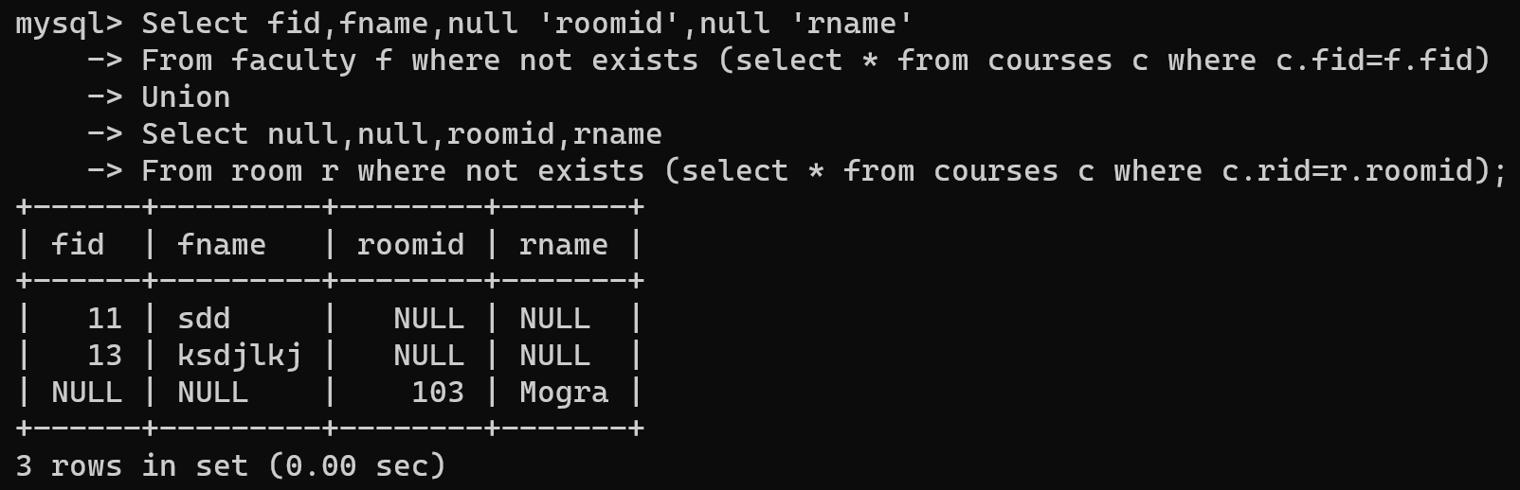

3. list all rooms which are allocated or not allocated to any courses

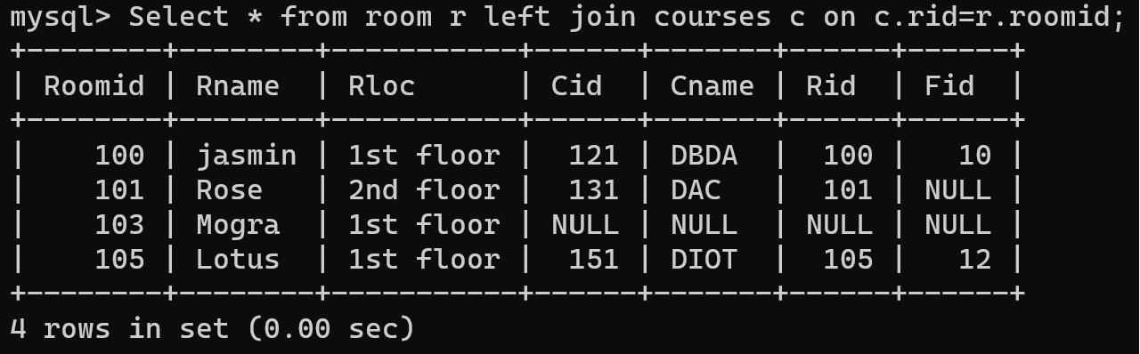

4. list all rooms which are not allocated to any courses

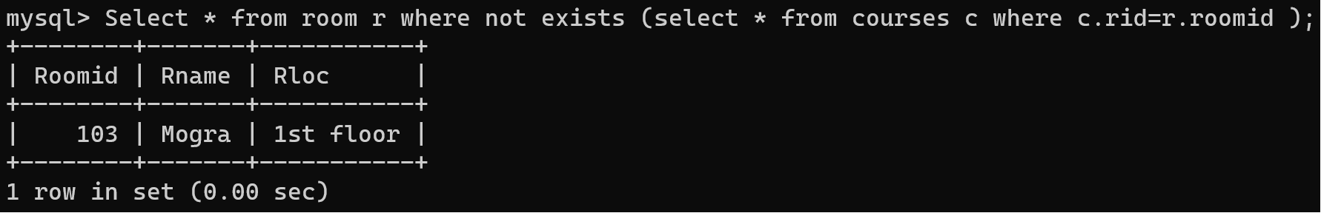

5. display courses and faculty assigned to those courses whose special skill is database

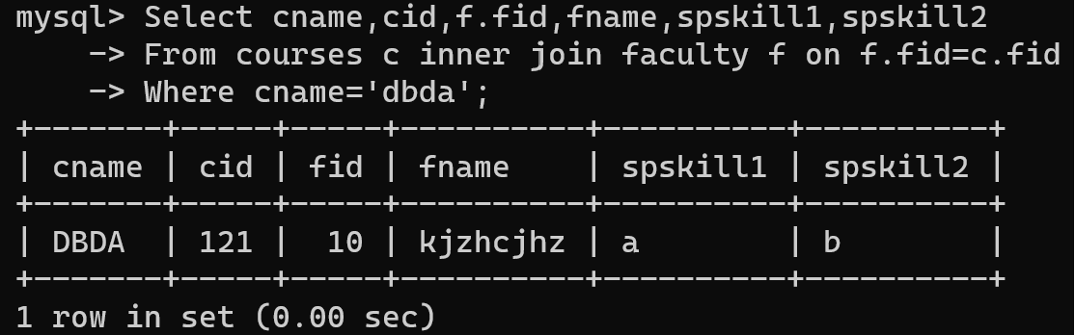

6. display time table --- it should contain course details , faculty and room details

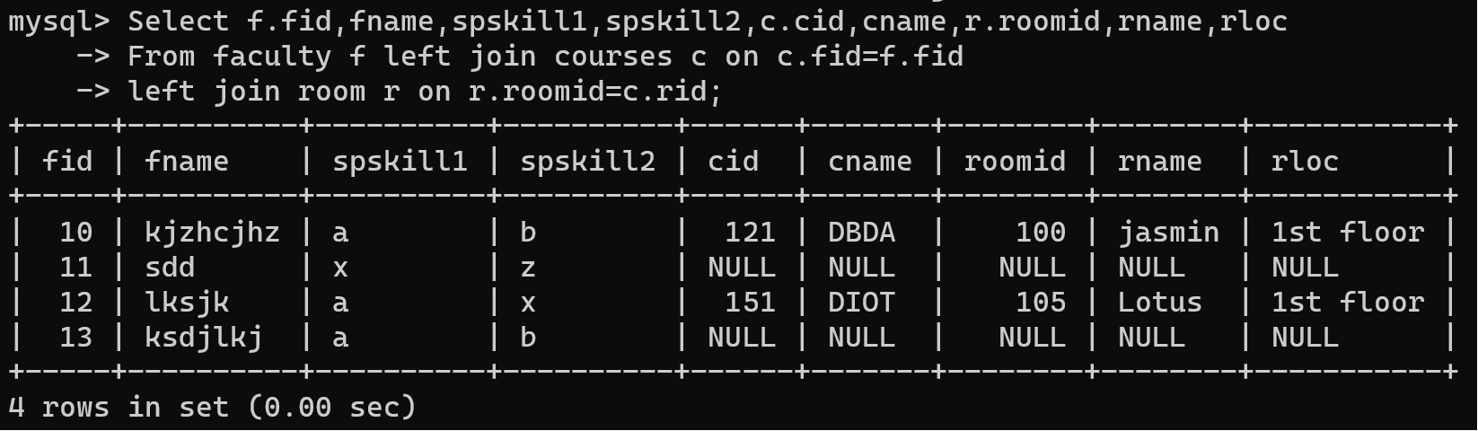

56. create following tables with given constraints

product---- qty >0, default 20.00, pname not null and unique

prodid pname qty price catid sid

123 lays 30 30.00 1 12

111 pepsi 40 50.00 4 11

134 nachos 50 50.00 1 12

124 dairy milk 40 60.00 2 14

124 pringles 40 60.00 1 14

saleman ----- sname -----not null

sid sname city

11 Rahul Pune

12 Kirti Mumbai

13 Prasad Nashik

14 Arnav Amaravati

category ---- cname unique and not null

cid cname description

1 chips very crunchy

2 chocolate very chocolaty

3 snacks yummy

4 cold drinks thanda thanda cool cool

1. List all products with category chips

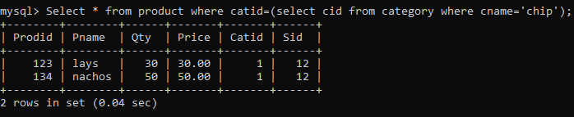

2. display all products sold by kirti

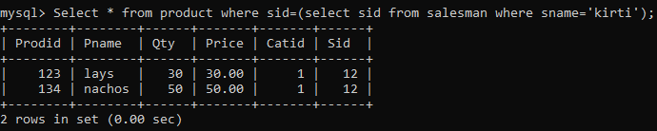

3. display all salesman who do not sold any product

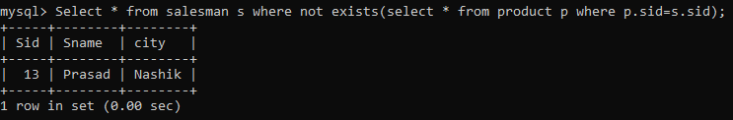

4. display all category for which no product is there

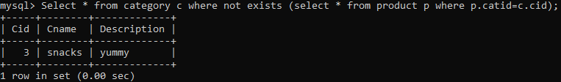

5. display all products with no category assigned



6. list all salesman who stays in city with name starts with P or N

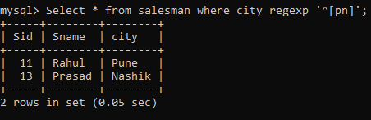

7. add new column in salesman table by name credit limit 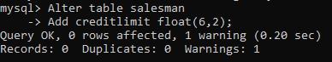

**Assignment:03**1. create all given tables

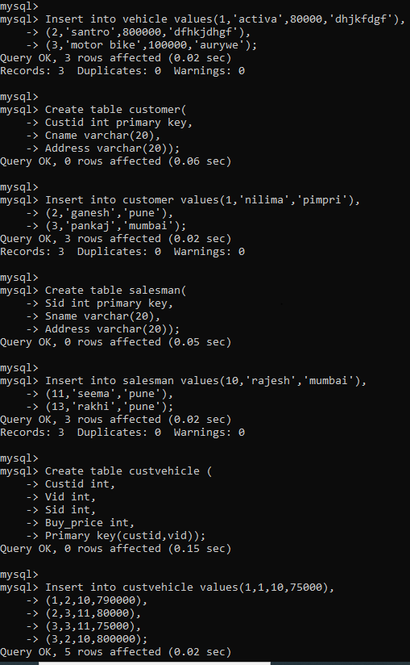

2. create index on vehicle table based on price

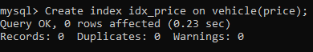

3. find all customer name,vehicle name, salesman name, discount earn by all customer

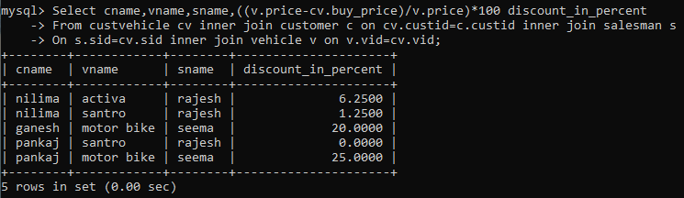

4. find all customer name,vehicle name,salesman name for all salesman who stays in pune

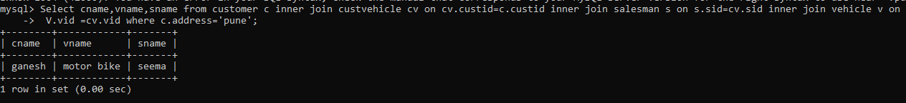

5. find how many customers bought motor bike

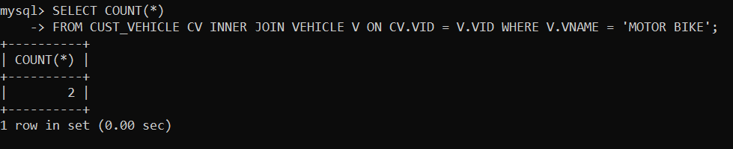

6. create a view find_discount which displays output

-------to create view

create view find_discount

as

select cname,vname,price,buying_price,price-buying_price “discount”

from customer c inner join cust_vehicle cv on c.custid=cv.cid inner join vehicle v on

v.vid=cv.vid

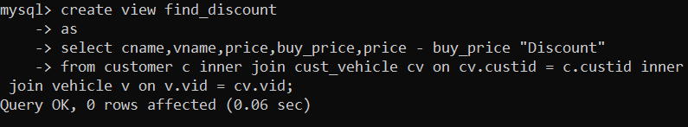

--------to display discount

select * from find_discount;

7. find all customer name, vehicle name, salesman name, discount earn by all customer

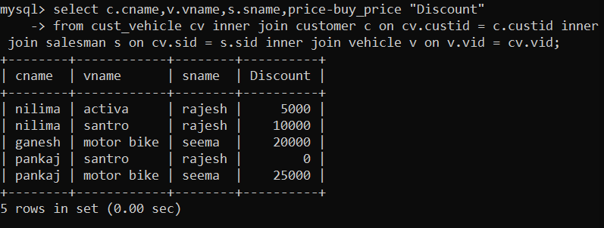

8. create view my_hr to display empno,ename,job,comm for all employees who earn commission

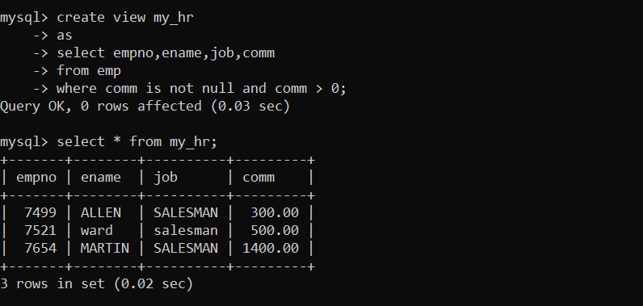

9. create view mgr30 to display all employees from department 30

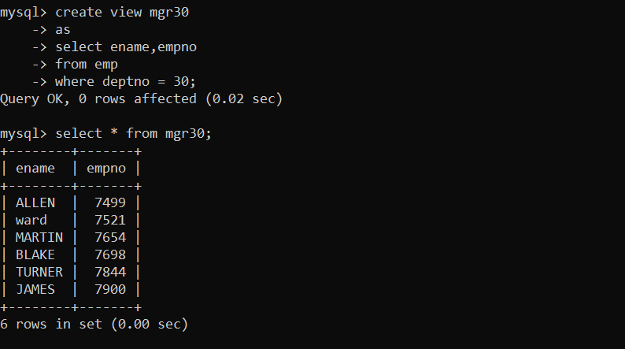

10. insert 3 employees in view mgr30 check whether insertion is possible

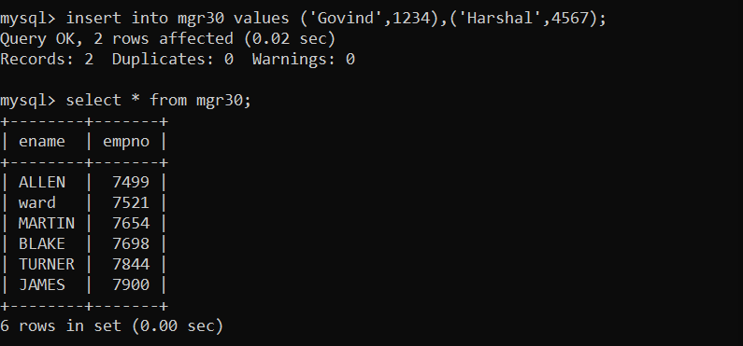

NOT POSSIBLE.

11. insert 3 records in dept and display all records from dept

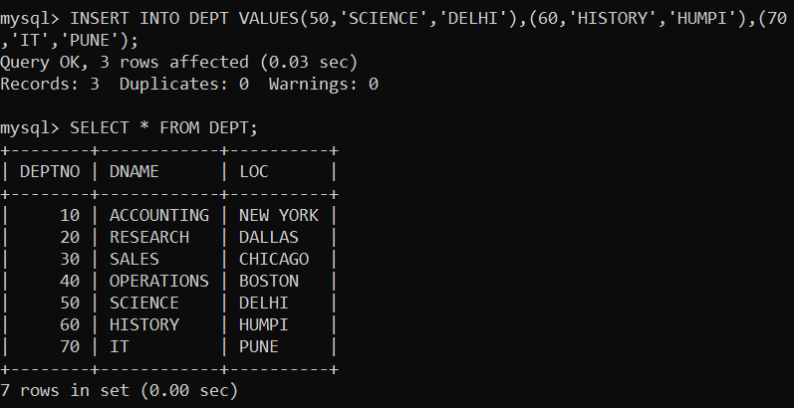

12. use rollback command check what happens

13. do the following

insert row in emp with empno 100

insert row in emp with empno 101

insert row in emp with empno 102

add savepoint A

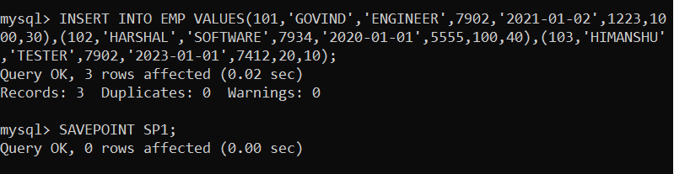

insert row in emp with empno 103

insert row in emp with empno 104

insert row in emp with empno 105

add savepoint B

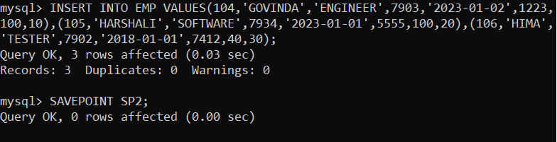

delete emp with empno 100

delete emp with emp no 104

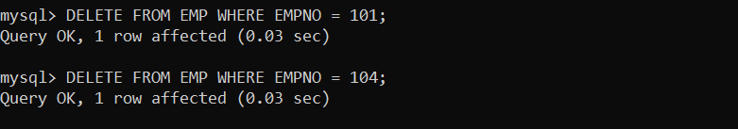

rollback upto svaepoint B



check what all records will appear in employee table

rollback upto A

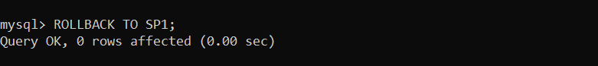

check what all records will appear in employee table

commit all changes



check what all records will appear in employee table

check whether you can roll back the contents.

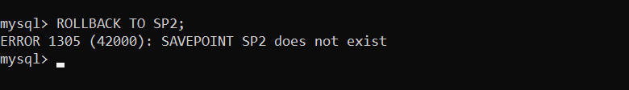

14. create a procedure getMin(deptno,minsal) to find minimum salary of given table.

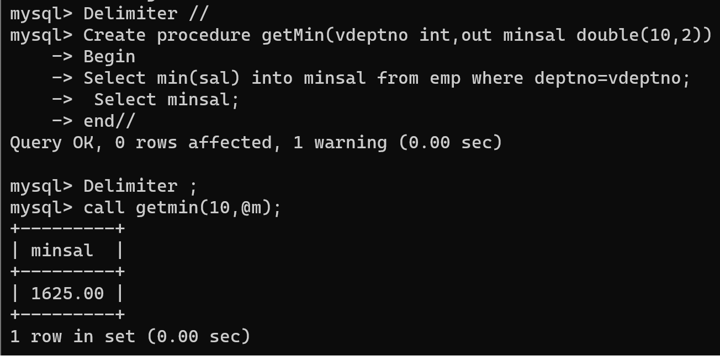

**Assignment: pl sql**

Solve the following

1. write a procedure to insert record into employee table.

the procedure should accept empno, ename, sal, job, hiredate as input parameter

write insert statement inside procedure insert_rec to add one record into table

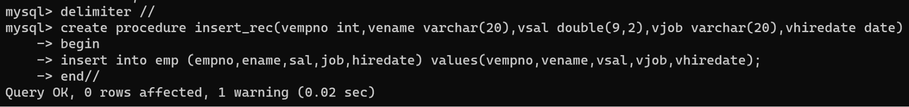



2. write a procedure to delete record from employee table.

the procedure should accept empno as input parameter.

write delete statement inside procedure delete_emp to delete one record from emp table

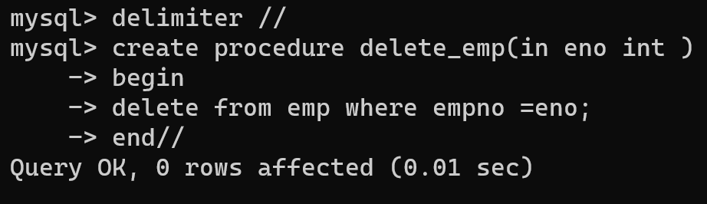

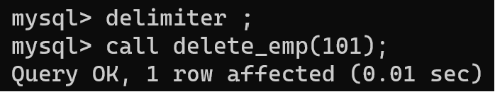

3. write a procedure to display empno,ename,deptno,dname for all employees with sal

>given salary. pass salary as a parameter to procedure

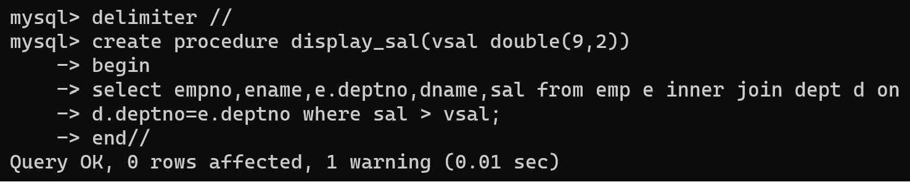

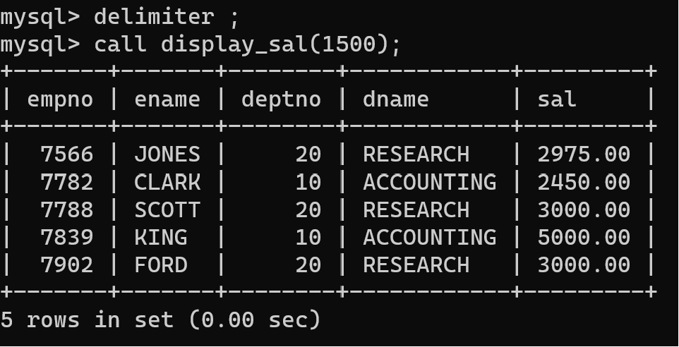

4. write a procedure to find min,max,avg of salary and number of employees in the

given deptno.

deptno --→ in parameter

min,max,avg and count ---→ out type parameter

execute procedure and then display values min,max,avg and count

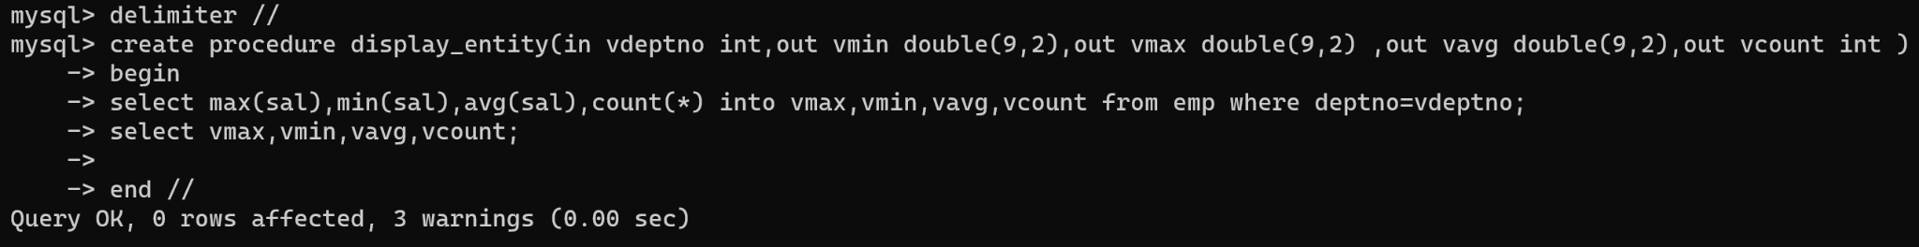

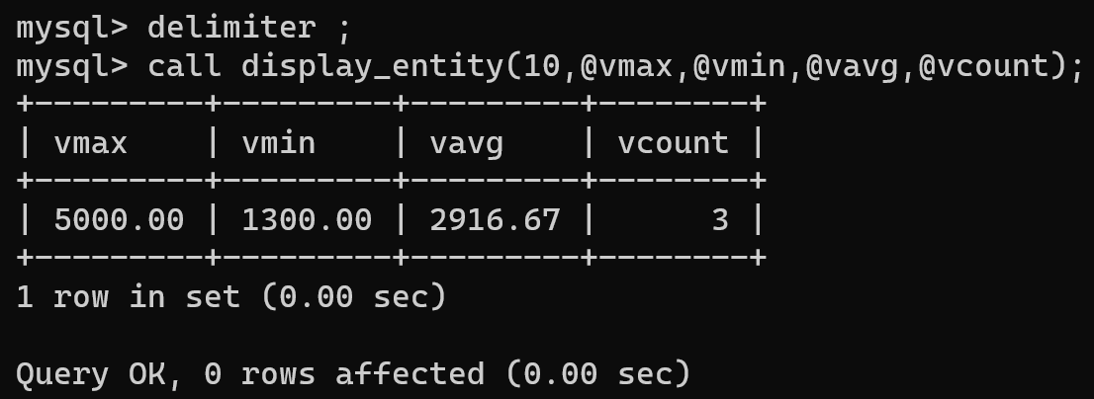

5. write a procedure to display all pid,pname,cid,cname and salesman name(use

product,category and salesman table)

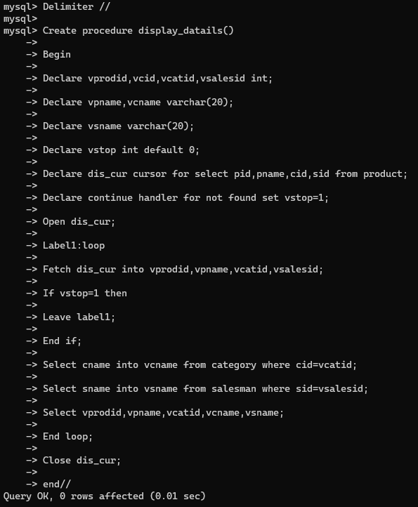

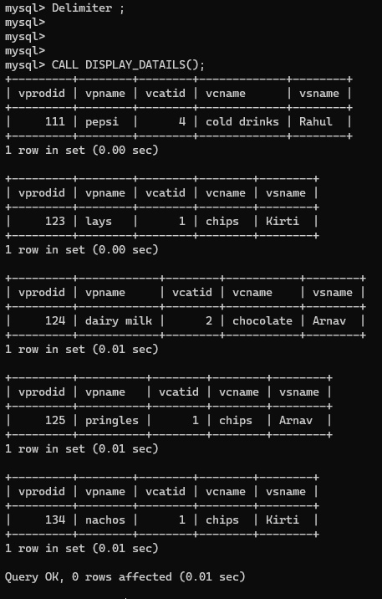

6. write a procedure to display all vehicles bought by a customer. pass customer name as

a parameter.(use vehicle,salesman,customer and relation table)

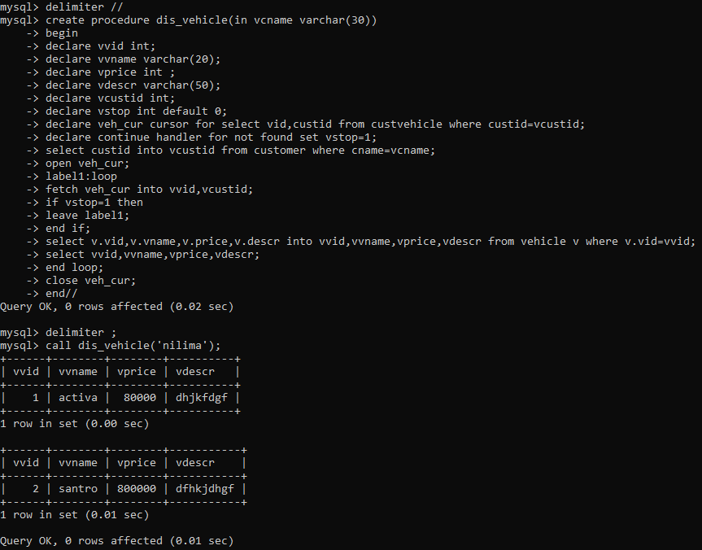

7. Write a procedure that displays the following information of all emp

Empno,Name,job,Salary,Status,deptno

Note: - Status will be (Greater, Lesser or Equal) respective to average salary of their own

department. Display an error message Emp table is empty if there is no matching record.

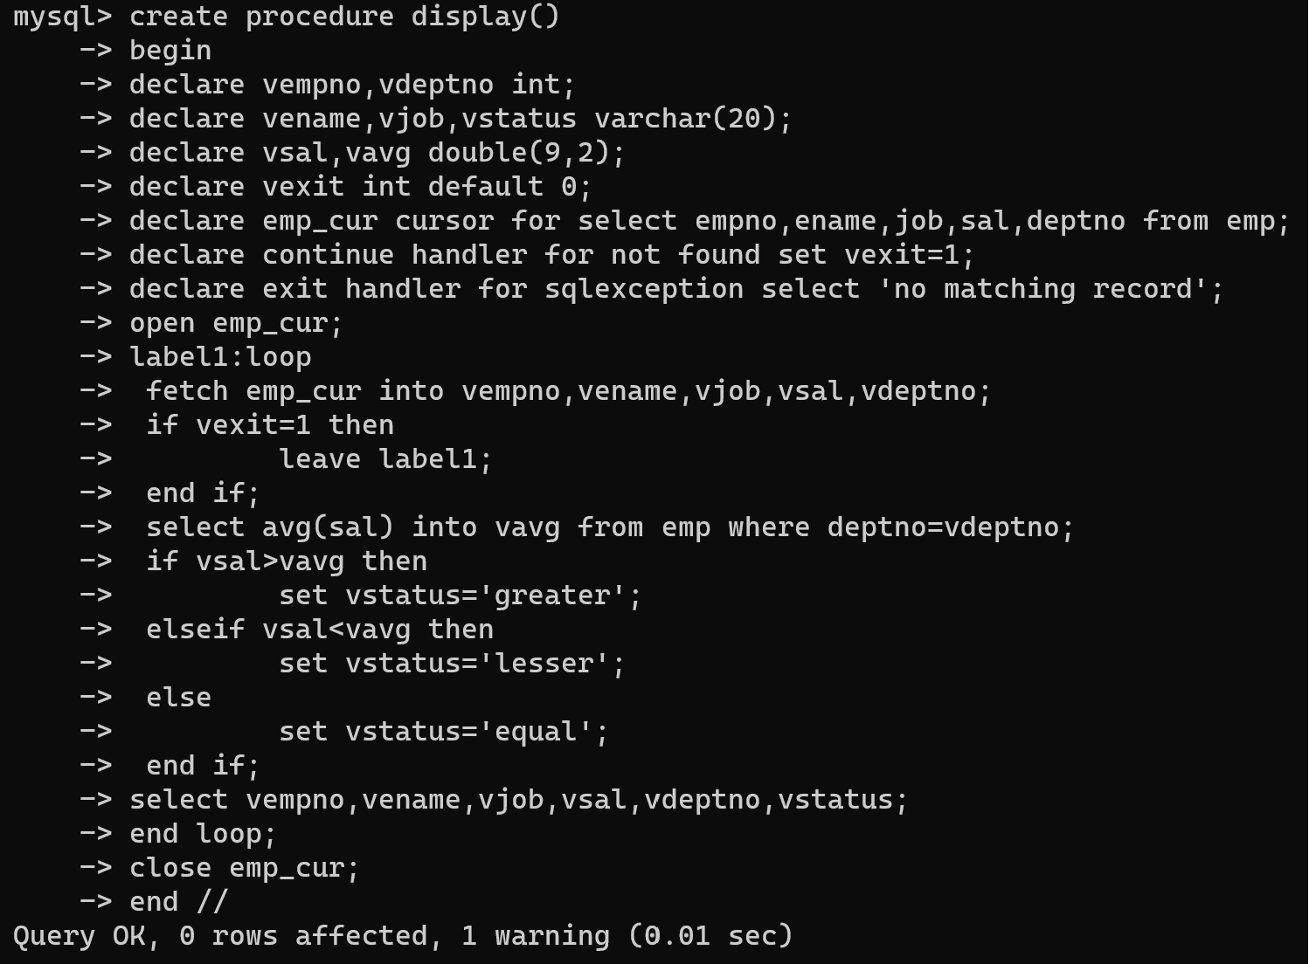

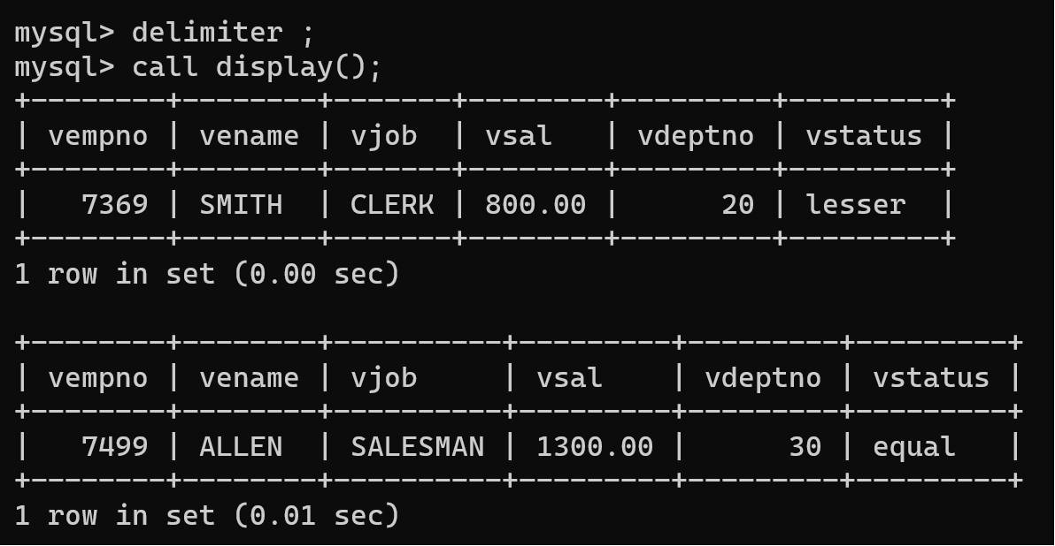

8. Write a procedure to update salary in emp table based on following rules.

Exp< =35 then no Update

Exp> 35 and <=38 then 20% of salary

Exp> 38 then 25% of salary

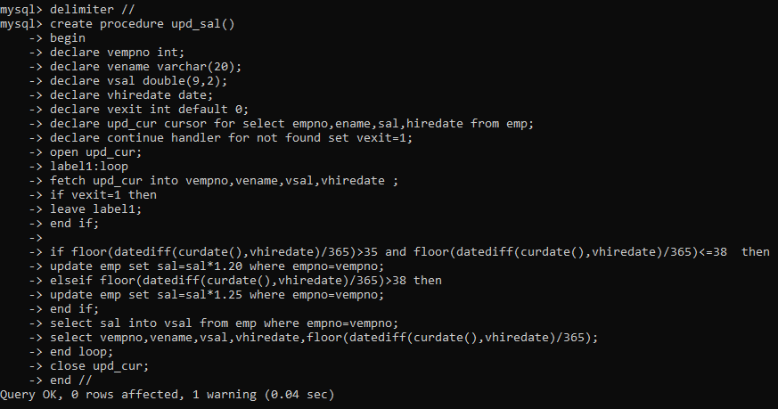

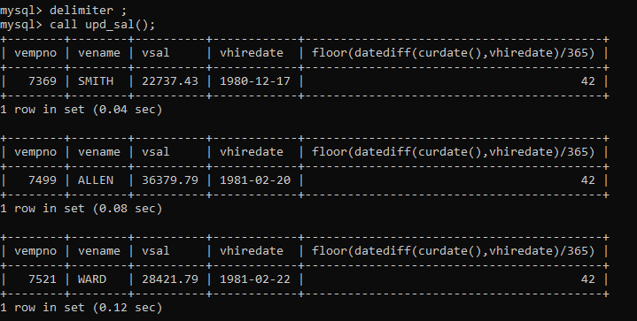

9. Write a procedure and a function.

Function: write a function to calculate number of years of experience of employee.(note:

pass hiredate as a parameter)

Procedure: Capture the value returned by the above function to calculate the additional

allowance for the emp based on the experience.

Additional Allowance = Year of experience x 3000

Calculate the additional allowance

and store Empno, ename,Date of Joining, and Experience in

years and additional allowance in Emp_Allowance table.

create table emp_allowance(

empno int,

ename varchar(20),

hiredate date,

experience int,

allowance decimal(9,2));

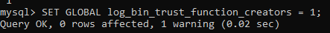

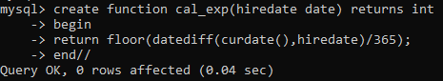

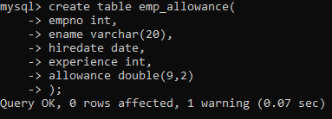

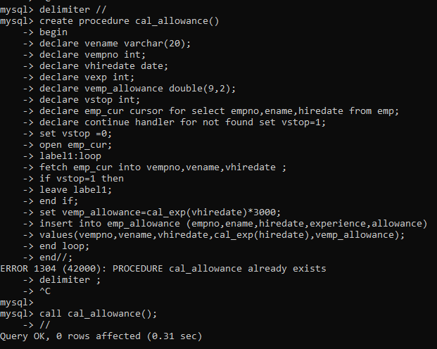

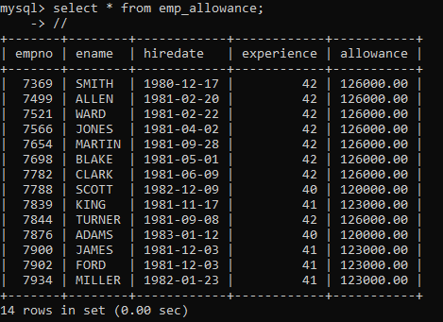

10. Write a function to compute the following. Function should take sal and hiredate

as i/p and return the cost to company.

DA = 15% Salary, HRA= 20% of Salary, TA= 8% of Salary.

Special Allowance will be decided based on the service in the company.

< 1 Year Nil

>=1 Year< 2 Year 10% of Salary

>=2 Year< 4 Year 20% of Salary

>4 Year 30% of Salary

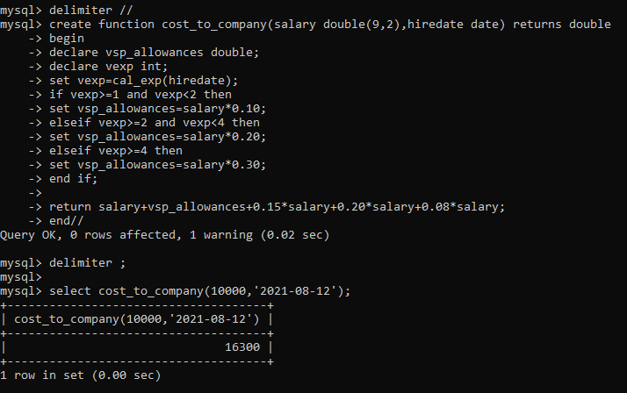

11. Write query to display empno,ename,sal,cost to company for all employees(note:

use function written in question 10)

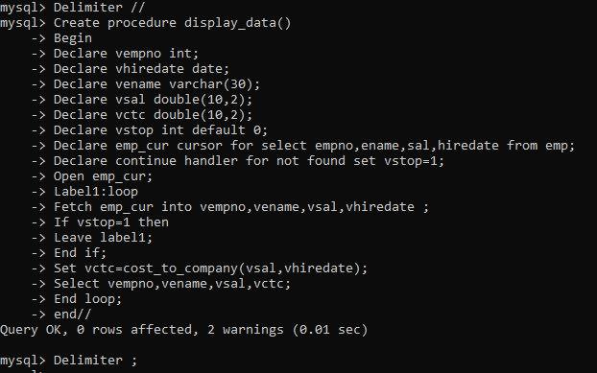

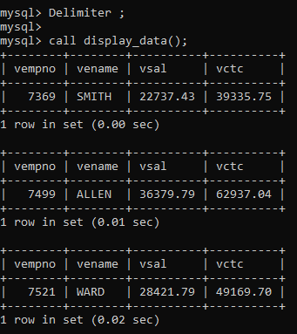

Q2. Write trigger

1. Write a tigger to store the old salary details in Emp _Back (Emp _Back has the

same structure as emp table without any

constraint) table.

(note :create emp_back table before writing trigger)

----- to create emp_back table

create table emp_back(

empno int,

ename varchar(20),

oldsal decimal(9,2),

newsal decimal(9,2)

)

(note :

execute procedure written in Q8 and

check the entries in EMP_back table after execution of the procedure)

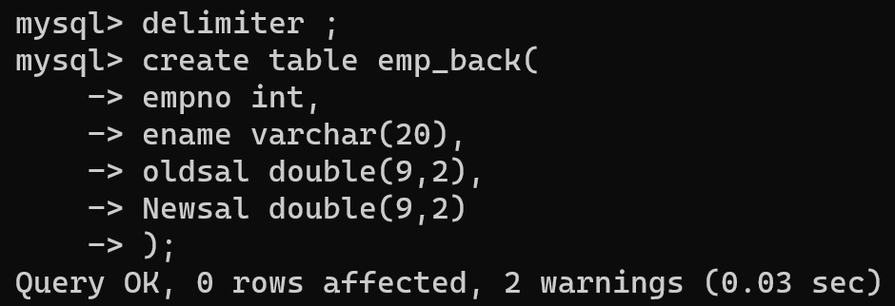

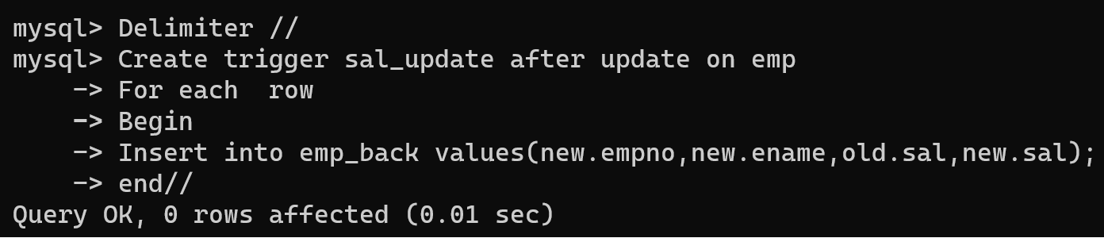

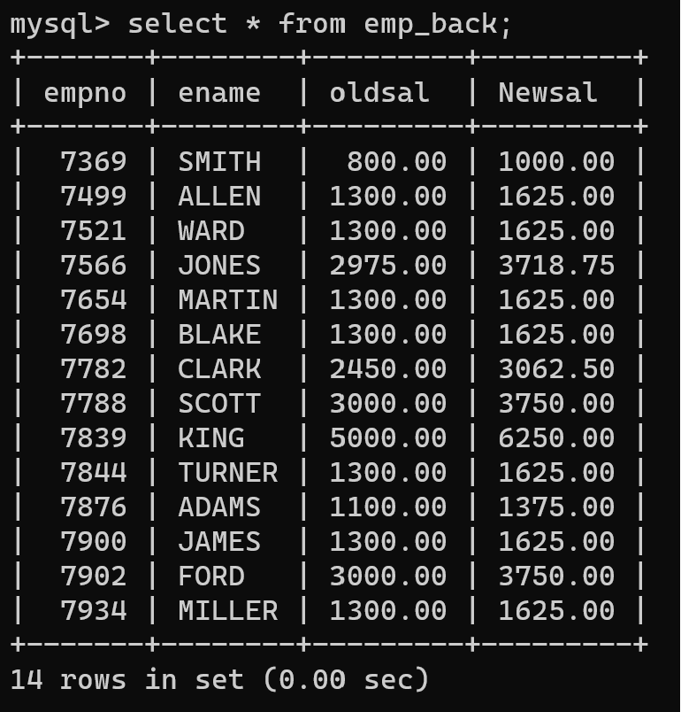

2. Write a trigger which add entry in audit table when user tries to insert or delete

records in employee table store empno,name,username and date on which

operation performed and which action is done insert or delete. in emp_audit table.

create table before writing trigger.

create table empaudit(

empno int;

ename varchar(20),

username varchar(20);

chdate date;

action varchar(20)

);

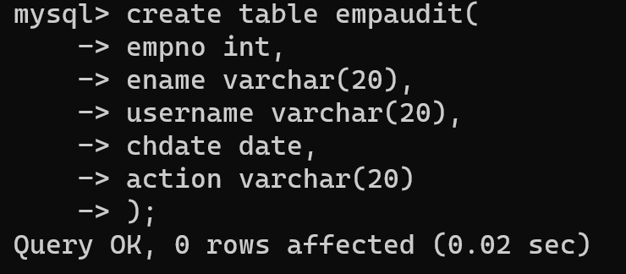

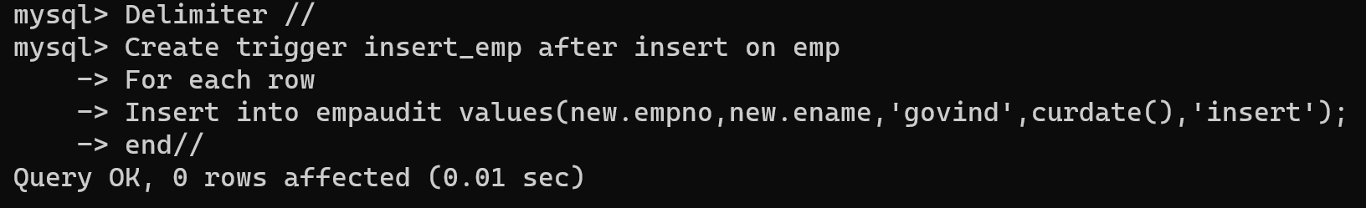

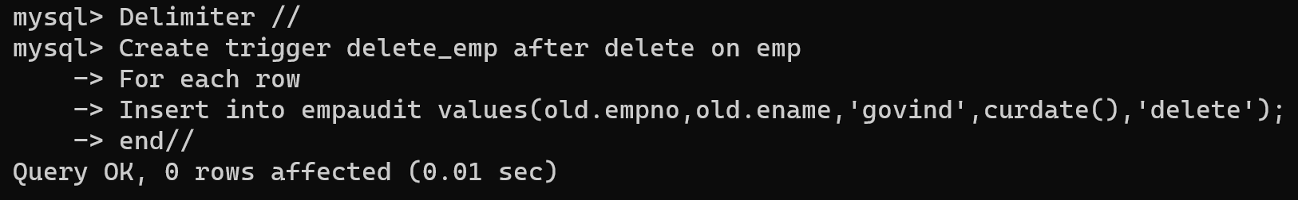

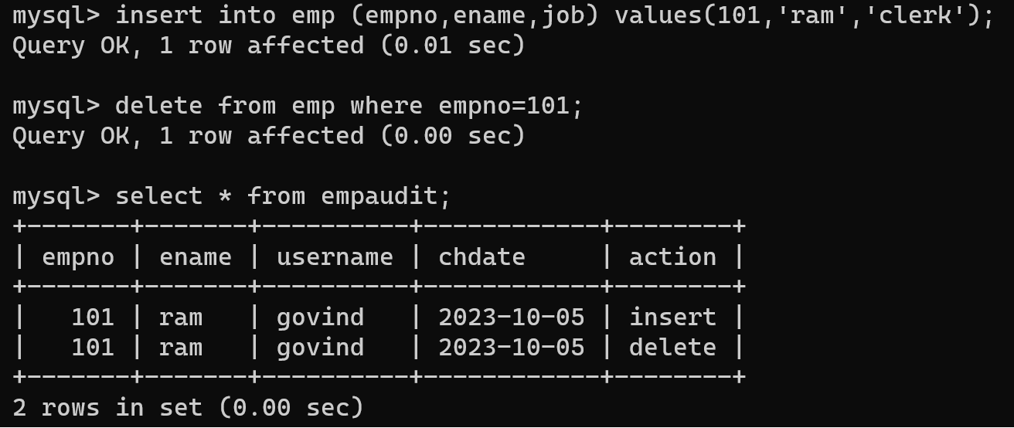

3. Create table vehicle_history. Write a trigger to store old vehicleprice and new vehicle

price in history table before you update price in vehicle table

(note: use vehicle table).

create table vehicle_history(

vno int,

vname varchar(20),

oldprice decimal(9,2),

newprice decimal(9,2),

chdate date,

username

create table vehicle_history(

vno int,

vname varchar(20),

oldprice double(9,2),

newprice double(9,2),

chdate date,

username varchar(20));

delimiter //

create trigger update_data after update on vehicle

for each row

begin

insert into vehicle_history values(old.vid,old.vname,old.price,new.price,curdate(),user());

end//

Delimiter ;

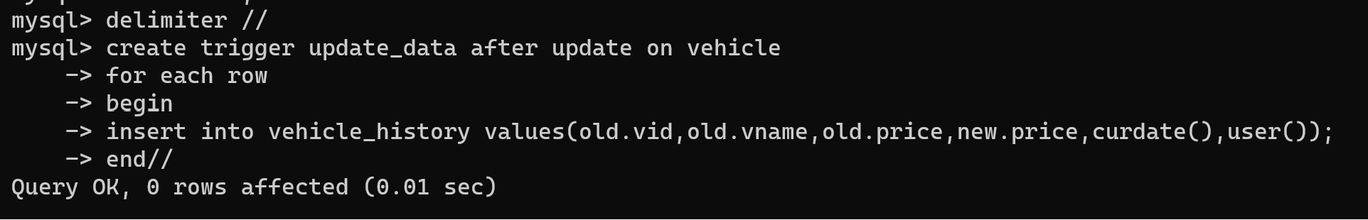

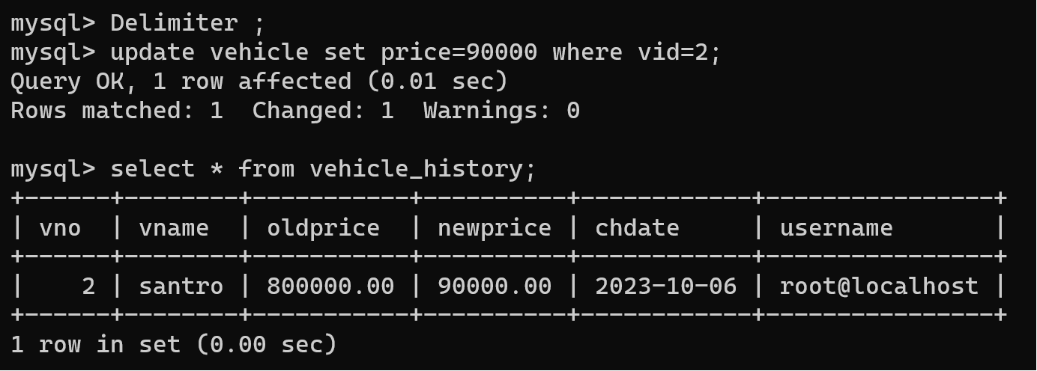

**Mongodb**

1. Write a MongoDB query to display all the documents in the collection restaurants

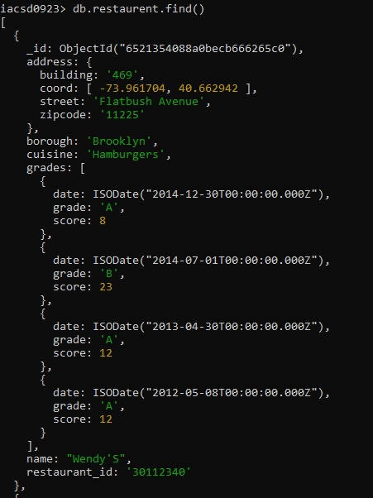

2. Write a MongoDB query to display the fields restaurant_id, name, borough and cuisine for

all the documents in the collection restaurant.

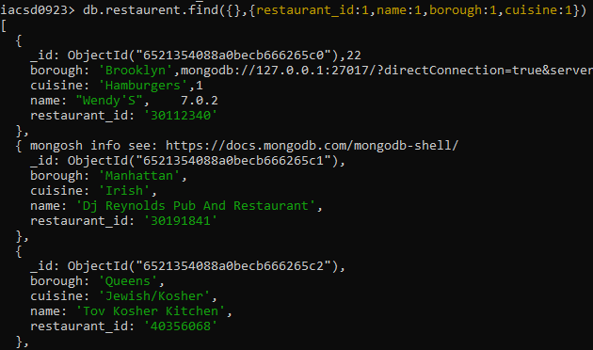

3. Write a MongoDB query to display the fields restaurant_id, name, borough and cuisine,

but exclude the field _id for all the documents in the collection restaurant.

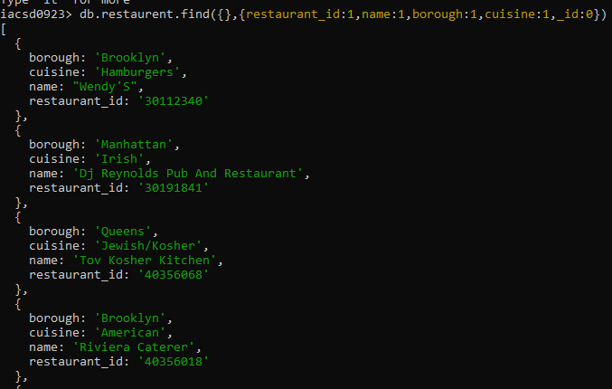

4. Write a MongoDB query to display the fields restaurant_id, name, borough and zip code,

but exclude the field _id for all the documents in the collection restaurant.

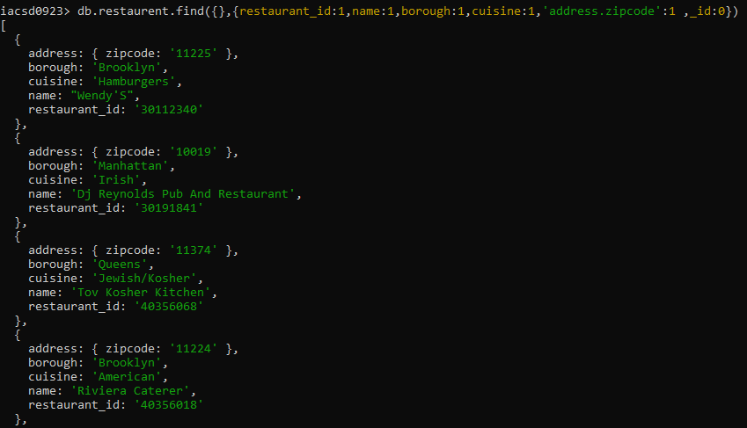

5. Write a MongoDB query to display all the restaurant which is in the borough Bronx

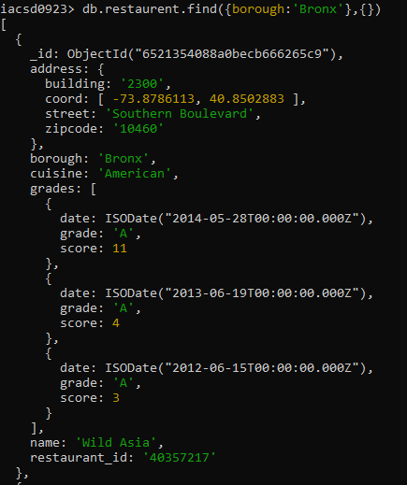

6. Write a MongoDB query to display the first 5 restaurant which is in the borough Bronx.

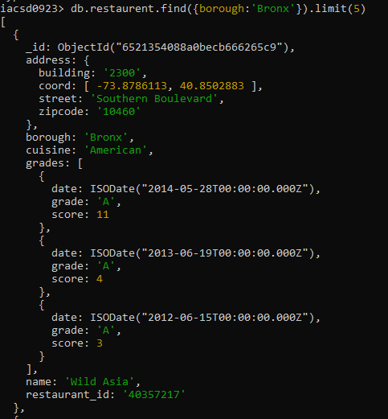

7.Write a MongoDB query to display the next 5 restaurants after skipping first 5 which are in the borough Bronx.

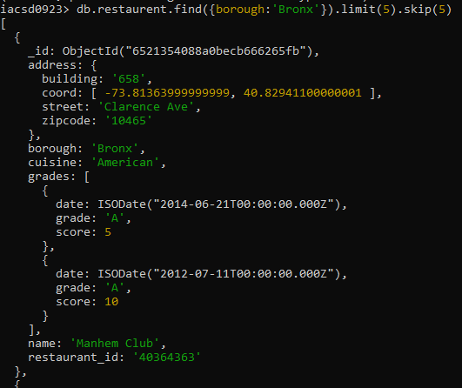

8. Write a MongoDB query to find the restaurants who achieved a score more than 90.

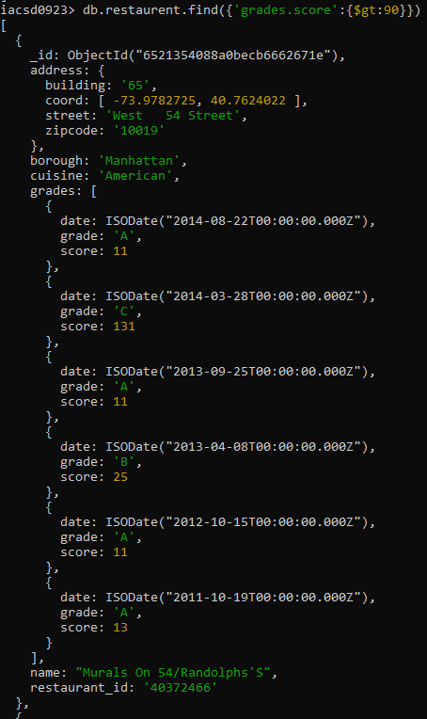

9. Write a MongoDB query to find the restaurants that achieved a score, more than 80 but

less than 100.

10. Write a MongoDB query to find the restaurants which locate in latitude value less than -

95.754168.

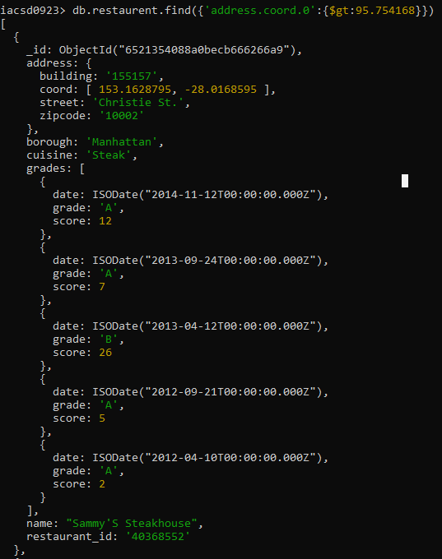

11. Write a MongoDB query to find the restaurants that do not prepare any cuisine of

'American' and their grade score more than 70 and latitude less than -65.754168.

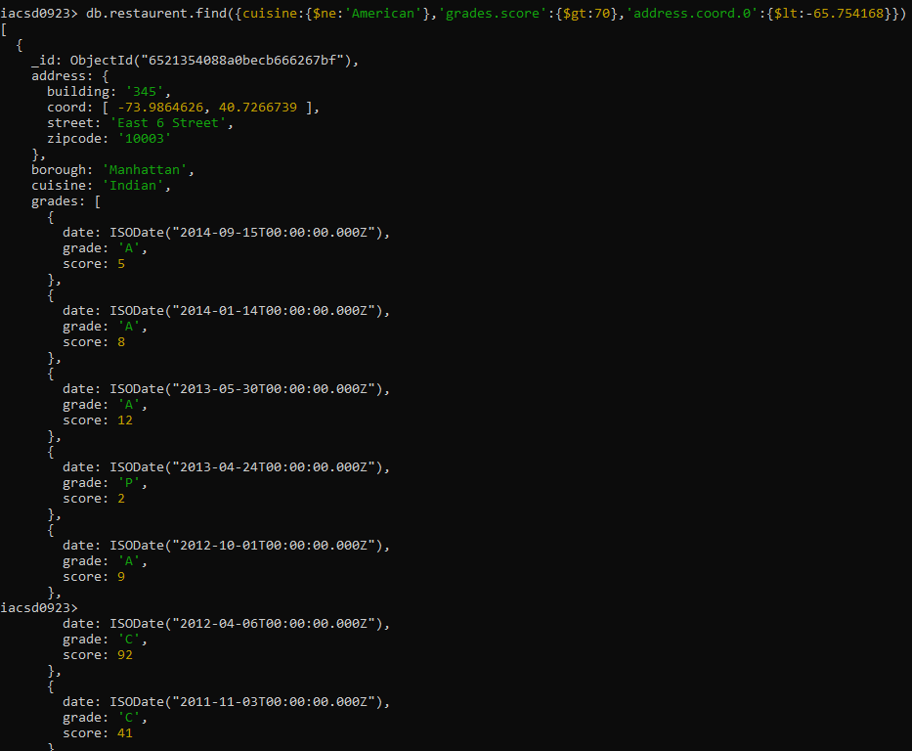

12. Write a MongoDB query to find the restaurants which do not prepare any cuisine of

'American' and achieved a score more than 70 and located in the longitude less than -

65.754168.

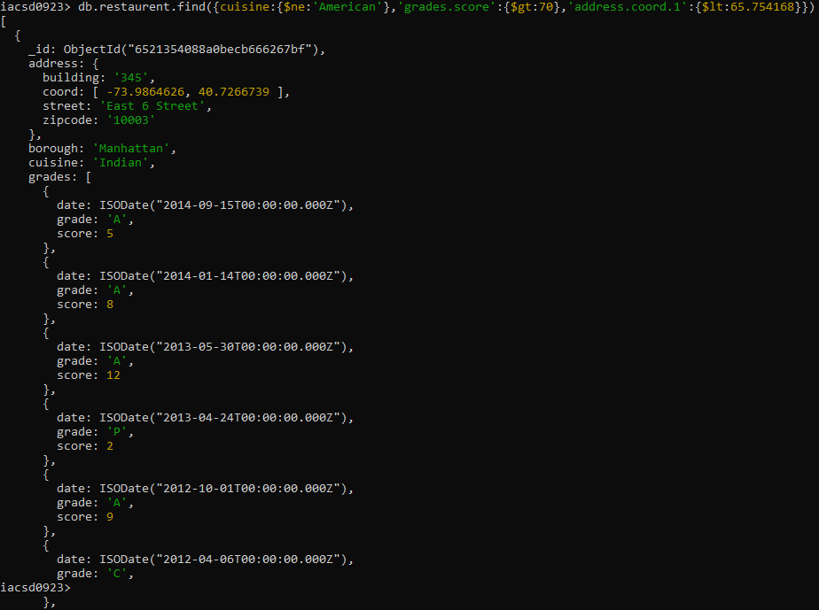

13. Write a MongoDB query to find the restaurants which do not prepare any cuisine of

'American ' and achieved a grade point 'A' not belongs to the borough Brooklyn. The

document must be displayed according to the cuisine in descending order.

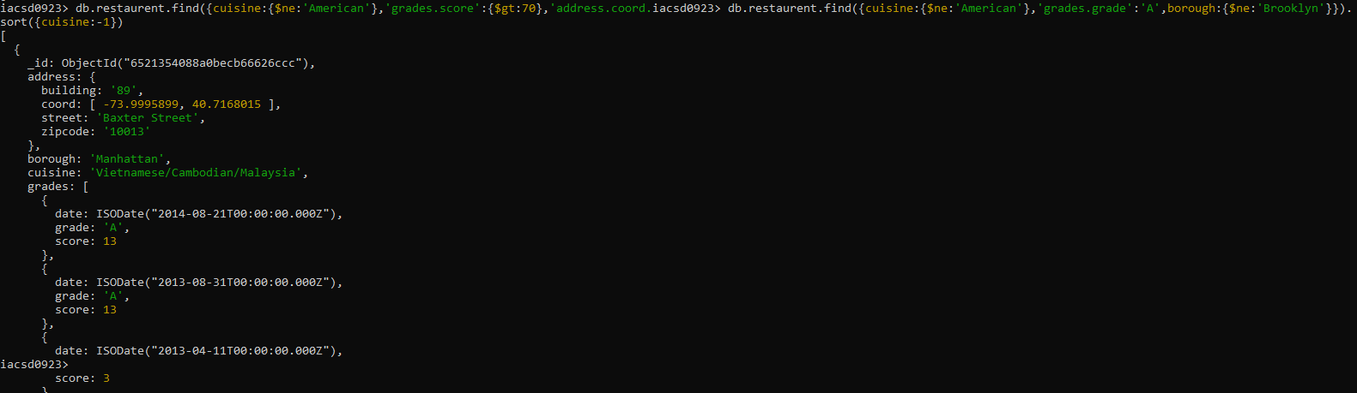

14. Write a MongoDB query to find the restaurant Id, name, borough and cuisine for those

restaurants which contain 'Wil' as first three letters for its name.

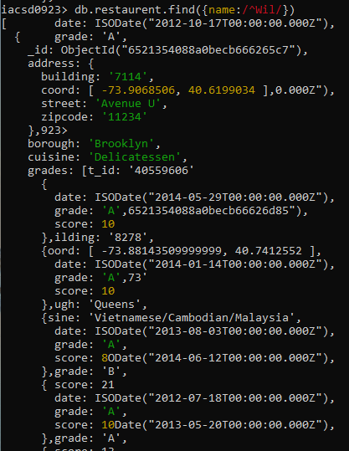

15. Write a MongoDB query to find the restaurant Id, name, borough and cuisine for those

restaurants which contain 'ces' as last three letters for its name.

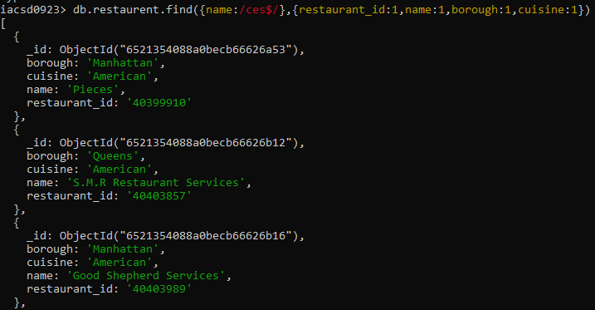

16. Write a MongoDB query to find the restaurant Id, name, borough and cuisine for those

restaurants which contain 'Reg' as three letters somewhere in its name.

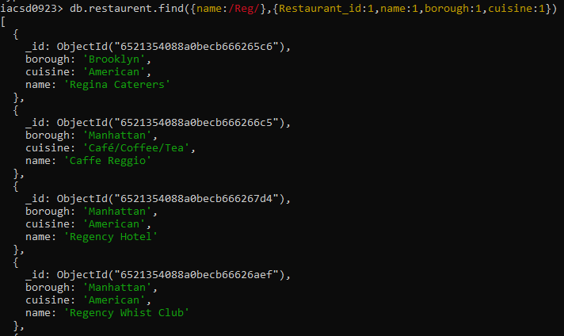

17. Write a MongoDB query to find the restaurants which belong to the borough Bronx and

prepared either American or Chinese dish.

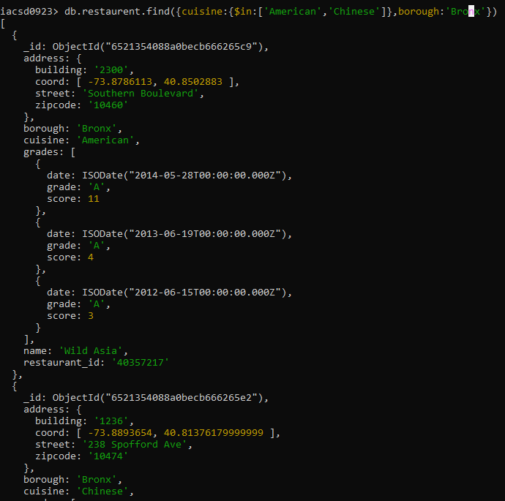

18. Write a MongoDB query to find the restaurant Id, name, borough and cuisine for those

restaurants which belong to the borough Staten Island or Queens or Bronxor Brooklyn.

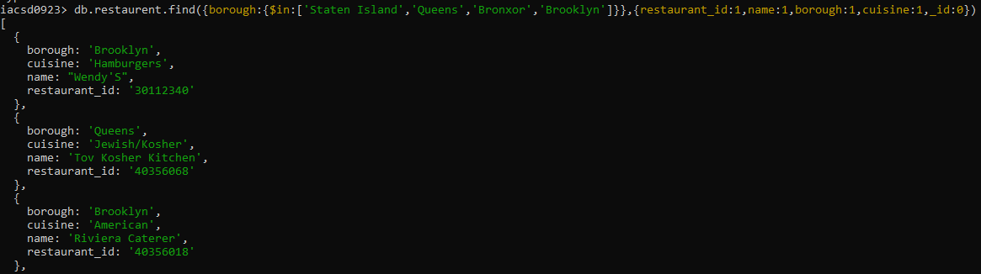

19. Write a MongoDB query to find the restaurant Id, name, borough and cuisine for those

restaurants which are not belonging to the borough Staten Island or Queens or Bronxor

Brooklyn.

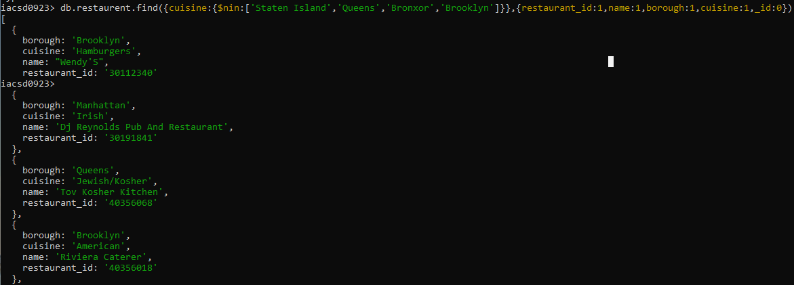

20. Write a MongoDB query to find the restaurant Id, name, borough and cuisine for those

restaurants which achieved a score which is not more than 10.

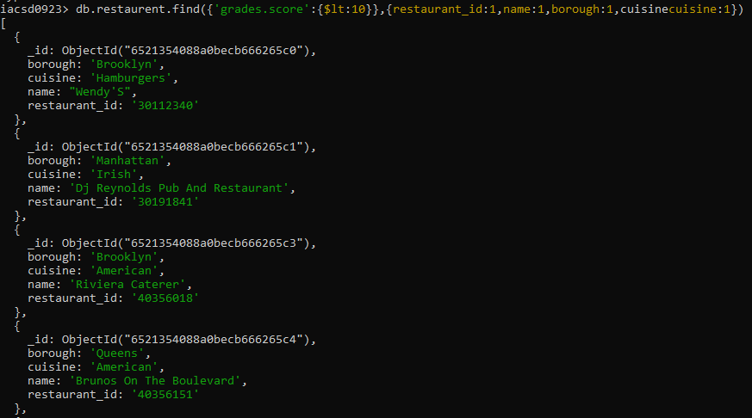

21. Write a MongoDB query to find the restaurant Id, name, borough and cuisine for those

restaurants which prepared dish except 'American' and 'Chinees' or restaurant's name begins

with letter 'Wil'.

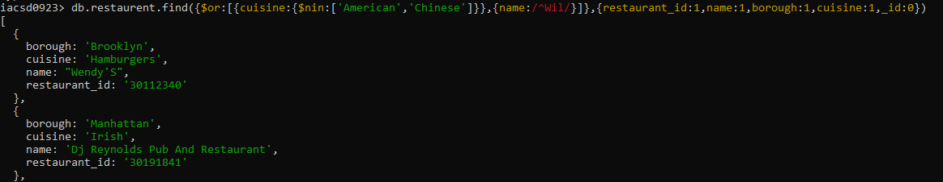

22. Write a MongoDB query to find the restaurant Id, name, and grades for those restaurants

which achieved a grade of "A" and scored 11 on an ISODate "2014-08-11T00:00:00Z"

among many of survey dates

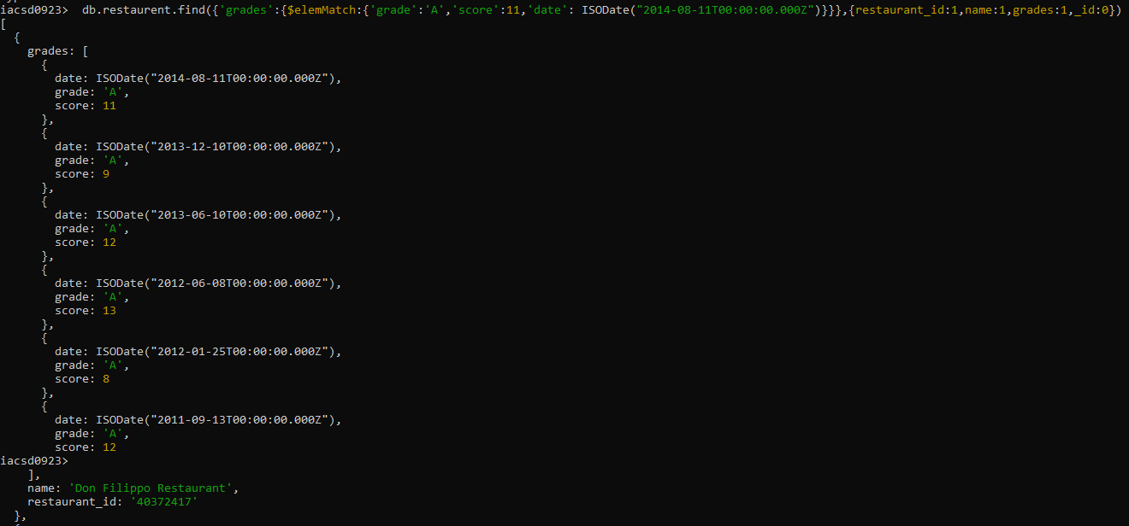

23. Write a MongoDB query to find the restaurant Id, name and grades for those restaurants

where the 2nd element of grades array contains a grade of "A" and score 9 on an ISODate

"2014-08-11T00:00:00Z".

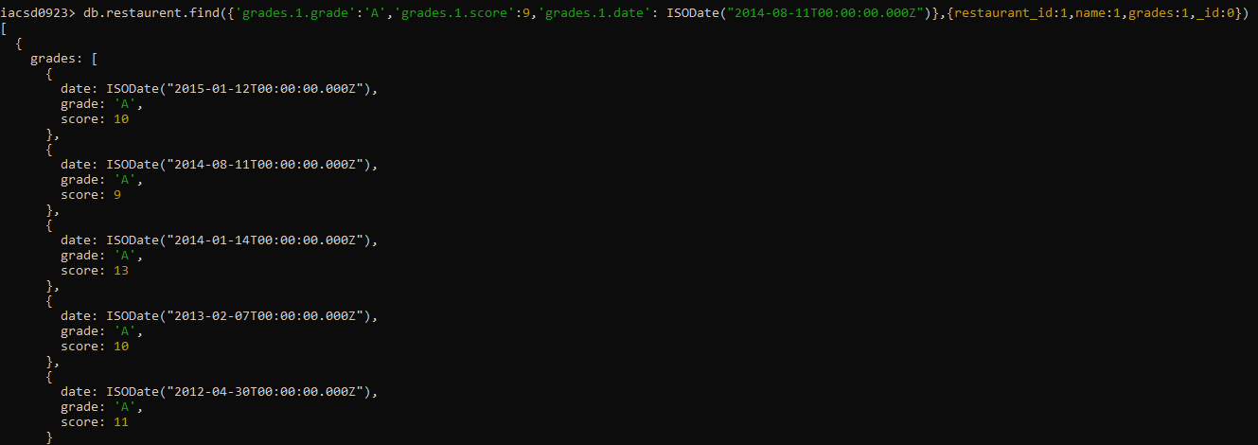

24. Write a MongoDB query to find the restaurant Id, name, address and geographical

location for those restaurants where 2nd element of coord array contains a value which is

more than 42 and upto 52

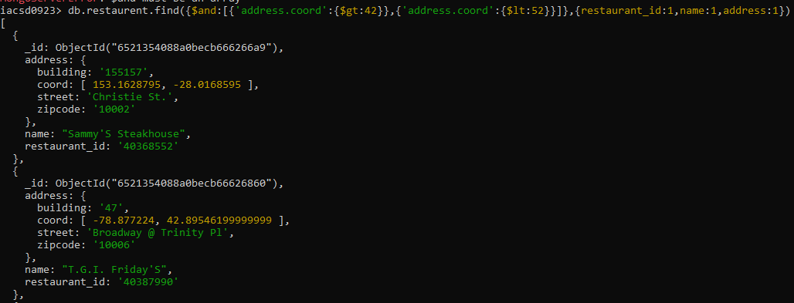

25. Write a MongoDB query to arrange the name of the restaurants in ascending order along with all the columns.

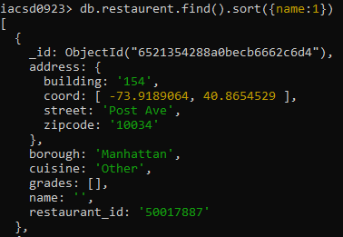

26. Write a MongoDB query to arrange the name of the restaurants in descending along with all the columns.

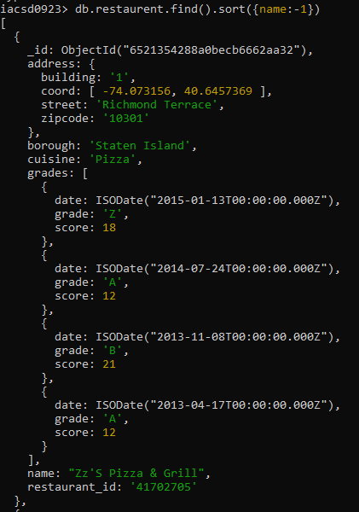

27. Write a MongoDB query to arranged the name of the cuisine in ascending order and for that same cuisine borough should be in descending order.

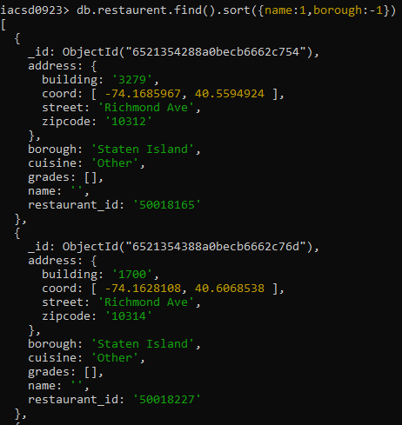

28. Write a MongoDB query to know whether all the addresses contains the street or not.

29. Write a MongoDB query which will select all documents in the restaurants collection

where the coord field value is Double.

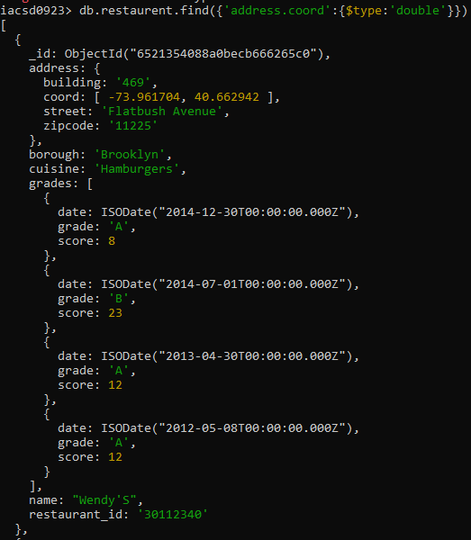

30. Write a MongoDB query which will select the restaurant Id, name and grades for those

restaurants which returns 0 as a remainder after dividing the score by 7.

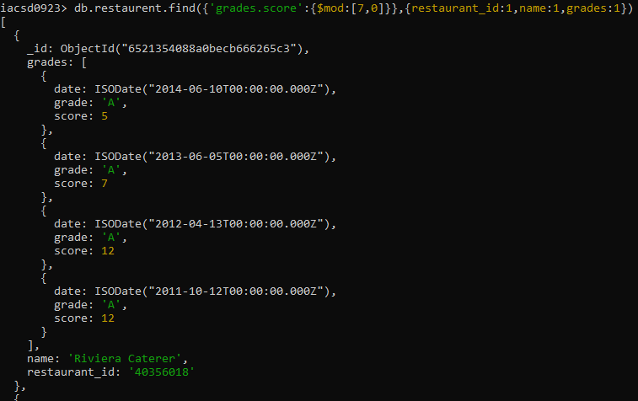

31. Write a MongoDB query to find the restaurant name, borough, longitude and attitude and

cuisine for those restaurants which contains 'mon' as three letters somewhere in its name.

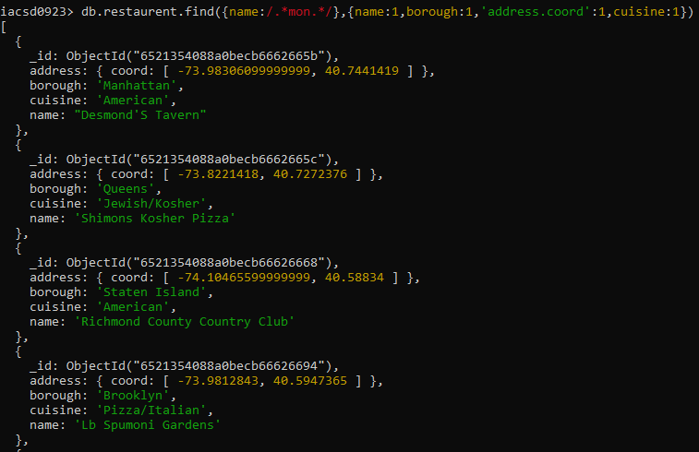

32. Write a MongoDB query to find the restaurant name, borough, longitude and latitude and

cuisine for those restaurants which contain 'Mad' as first three letters of its name.

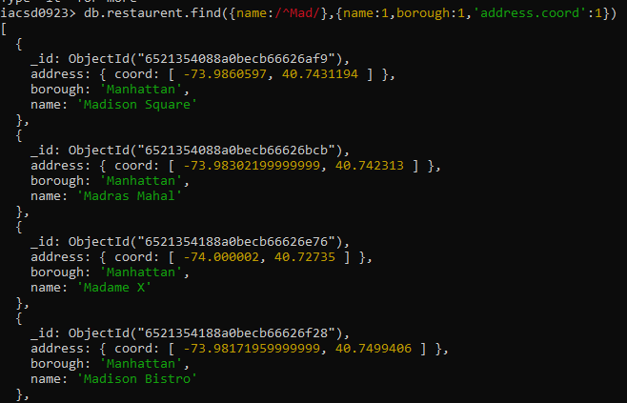

db.Employee.insertMany([{empno:111,ename:'Deepali Vaidya',sal:40000.00,dept:{deptno:12,dname:'HR',dloc:'Mumbai'},desg:'Analyst',mgr:{name:'satish',num:111},project:[{name:'Project-1',Hrs:4},{name:'Project-2',Hrs:4}] }])

**Update Assignment**

Create a Employee Collection add 5 documents:

Example:

{empno:111,ename:”Deepali

Vaidya”,sal:40000.00,dept:{deptno12,dname:,”Hr”,dloc:”Mumbai},

Desg:”Analyst”,mgr:{name:”Satish”,num:111},project:[{name:”Project-

1”,Hrs:4},{name:”project- 2”,Hrs:4}]}

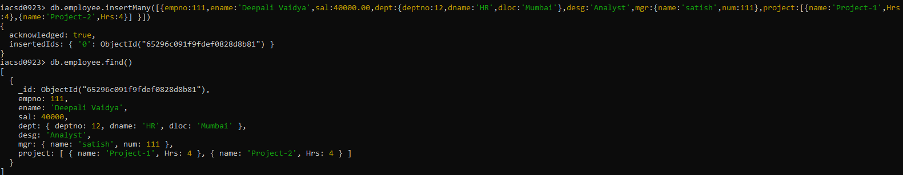

**:*Change:We have change some query value the according to the database**

1. All Employee’s with the desg as ‘CLERK’ are now called as (AO) Administrative Officers.

Update the Employee collection for this.

**\*change**

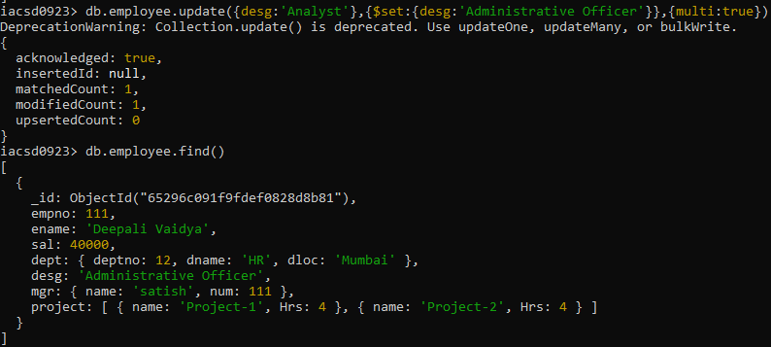

2. Change the number of hours for project-1 to 5 for all employees with designation analyst.

**\*change**

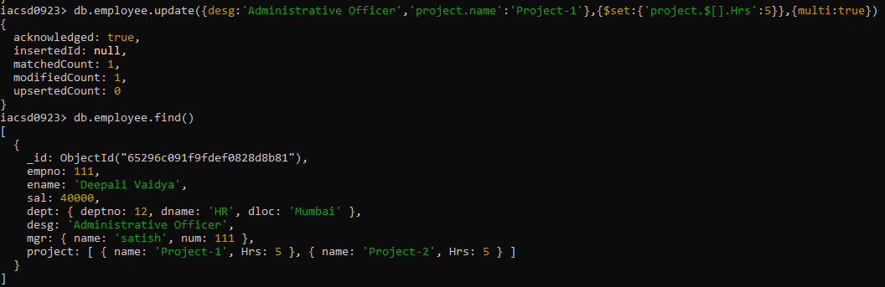

3. Add 2 projects project-3 and project-4 for employee whose name starts with ”Deep” with 2 hrs

db.employee.update({ename:/^Deep/},{$push:{project:{name:'Project-3',Hrs:2}}},{multi:true})

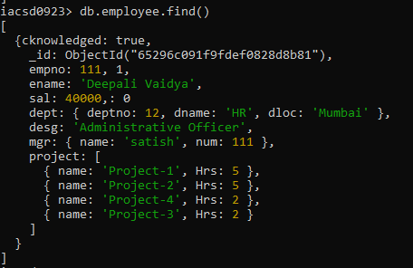

4. Add bonus rs 2000 for all employees with salary > 50000

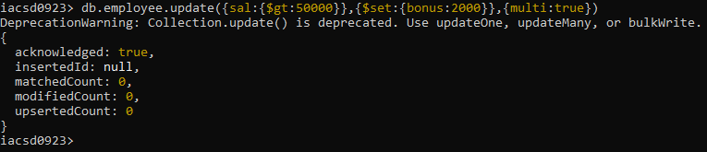

5. Add bonus rs 1500 if salary <50000 and > 30000

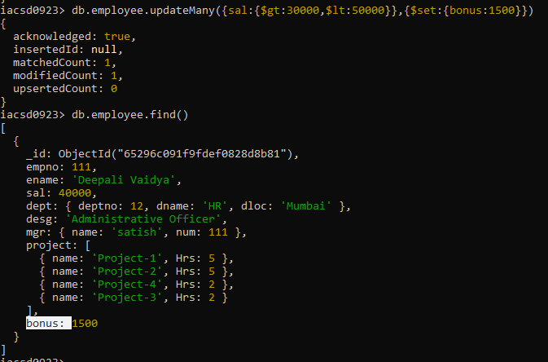

6. increment bounus by 1000 for all employees if salary <=30000

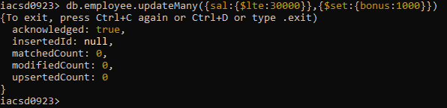

7. Change manager name to Tushar for all employees whose manager is currently “satish”

And manager number to 3333



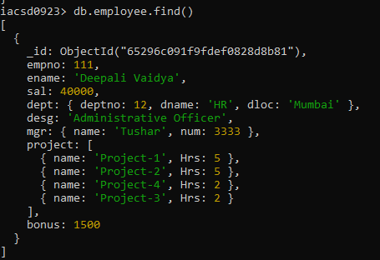

8. Increase salary of all employees from “purchase department” by 15000

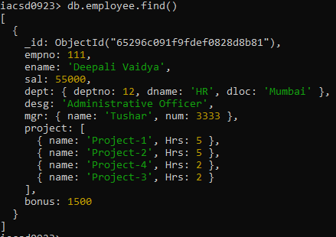

9. Decrease number of hrs by 2 for all employees who are working on project-2  
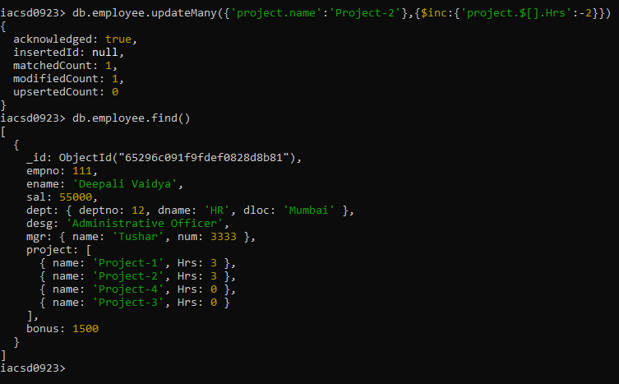

10. Delete project-2 from all employee document if they are working on the project for 4

Hrs.

db.employee.updateMany({'project.name':'Project-2'},{$pull:{'project.$[elem]':}})

11. Change the salary of employees to 10000 only if their salary is < 10000

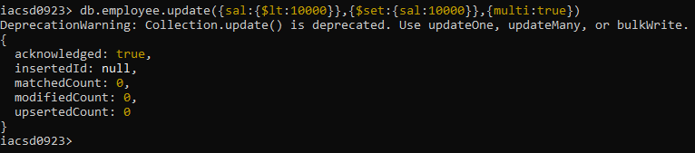

12. Increase bonus of all employees by 500 if the bonus is <2000 or their salary is <

20000 or if employee belong to sales department

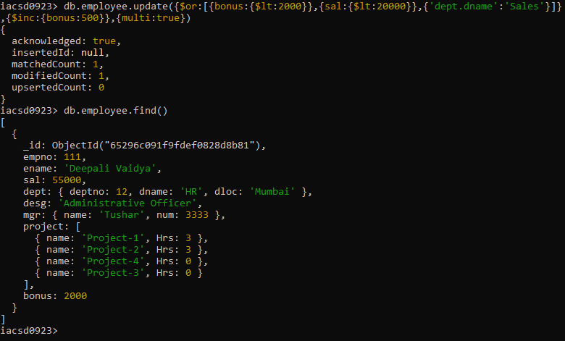

13. Add 2 new project at position 2 for all employees with designation analyst or salary is

equal to either 30000 or 33000 or 35000

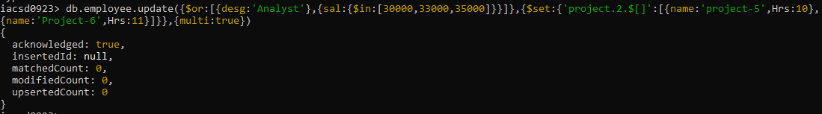

14. Delete last project of all employees with department name is “HR” and if the location

is Mumbai

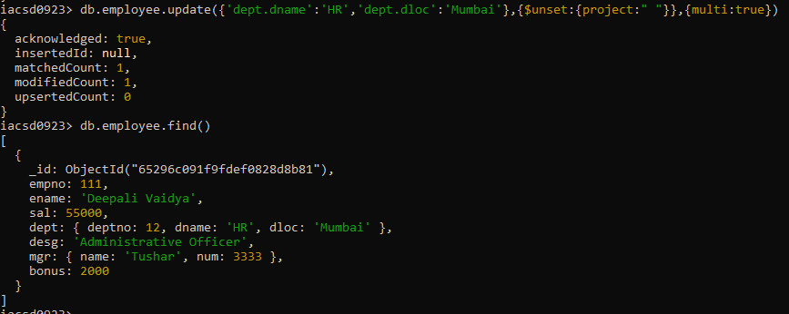

15. Change designation of all employees to senior programmer if they are working on

name:”Project-1” for 4 hrs

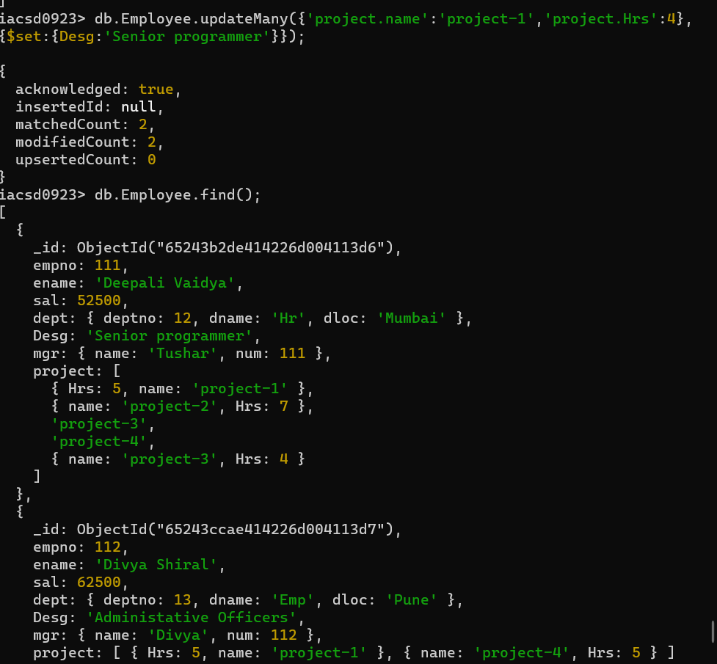

16. Add list of hobbies in all employees document whose manager is Rajan or Revati

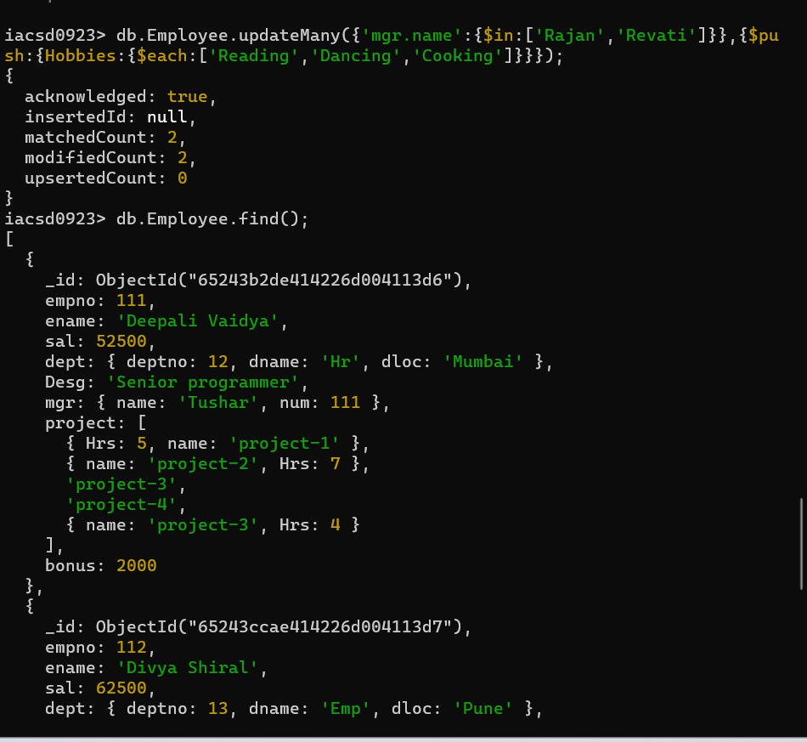

17. Add list of skillset in all employee documents who are working on project-4 for 3 hrs

or on project-3 for 4 hrs

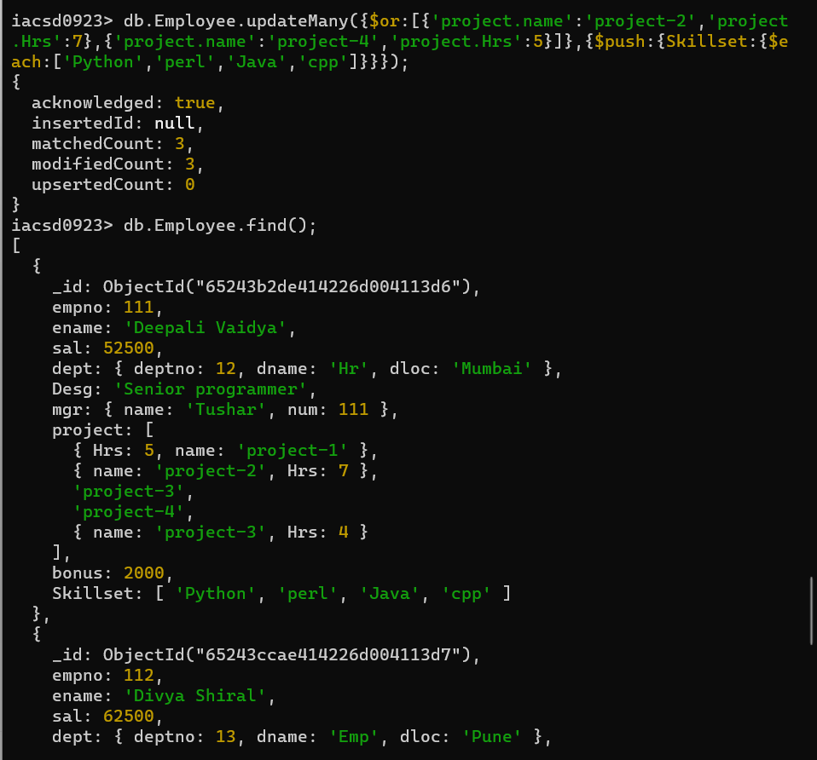

18. Add a new hobby as blogging at 3 position in hobbies array for all employess whose

name starts with R or p and ends with j or s

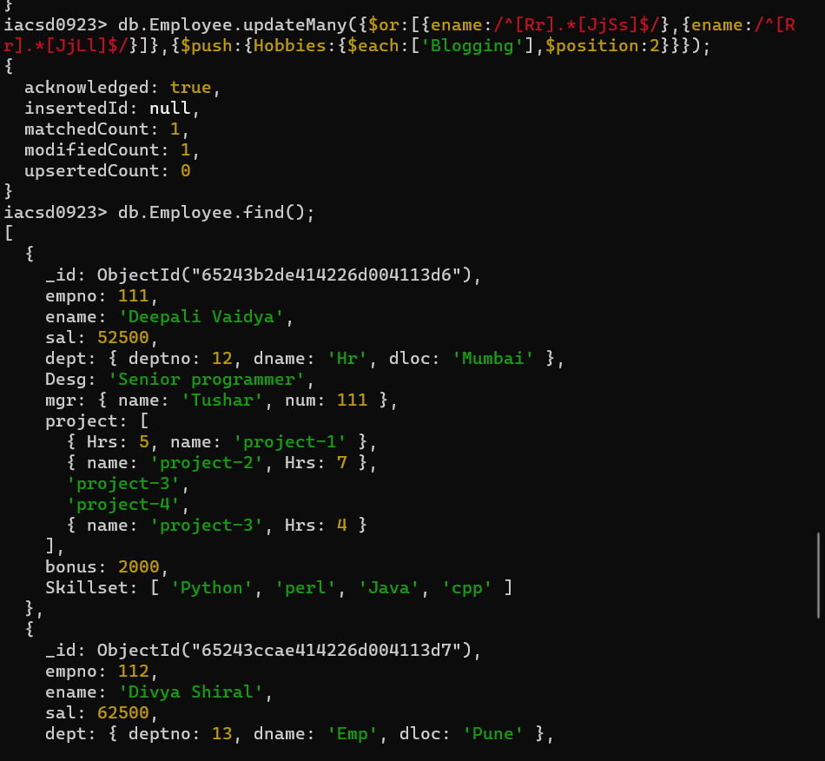

19. Increase salary by 10000 for all employees who are working on project-2 or project-3

or project-1 Decrease bonus by 1000 rs And increase salary by 1000rs for all employees whose

department location is Mumbai

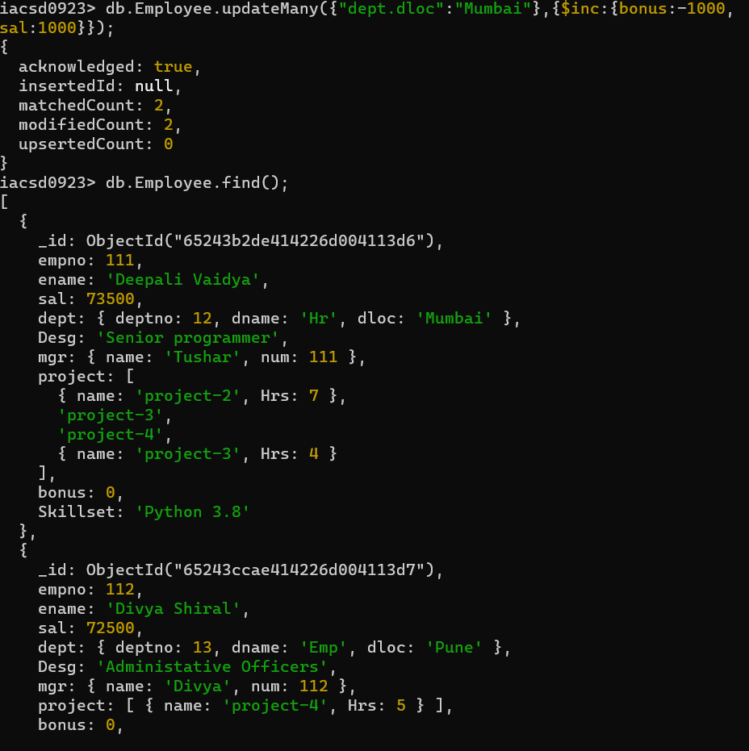

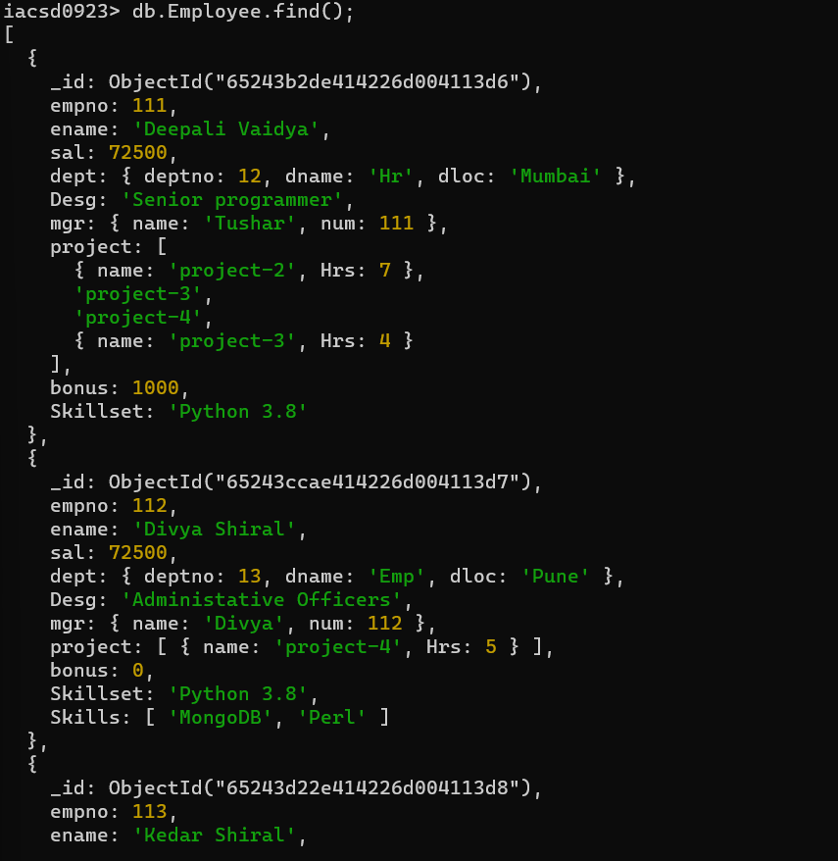

20. Remove all employees working on project-1



21. Replace document of employee with name “Deepak to some new document

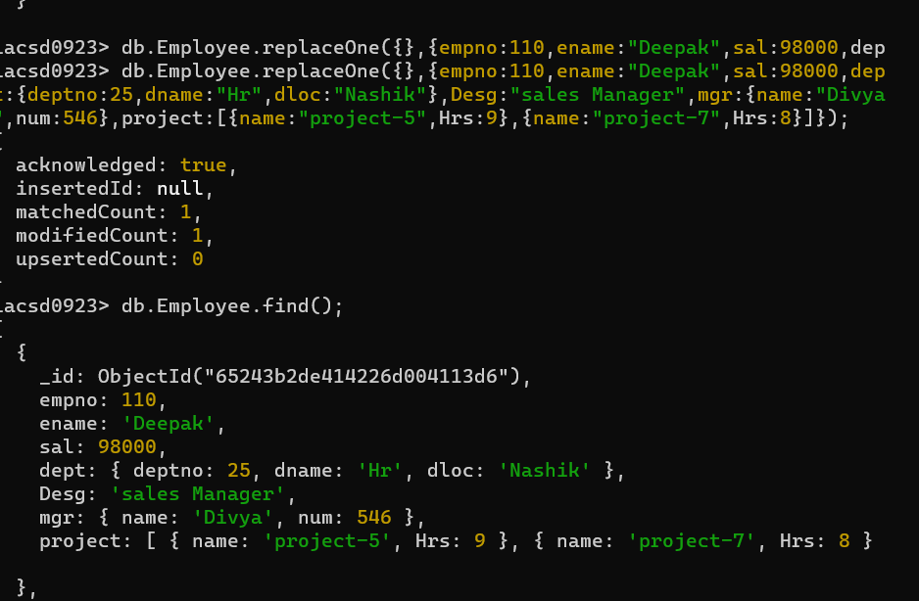

22. Change skill python to python 3.8 for all employees if python is there in the skillset

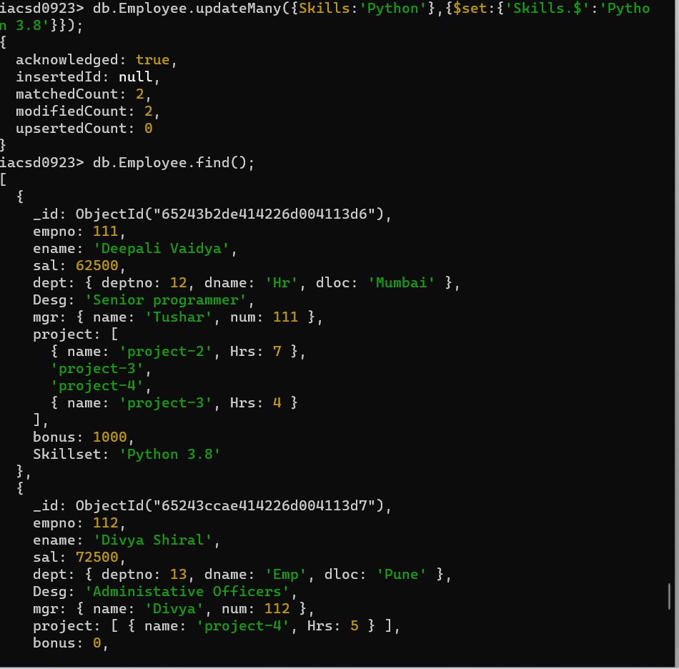

23. Add 2 skills MongoDb and Perl at the end of skillset array for all employees who are

working at Pune location

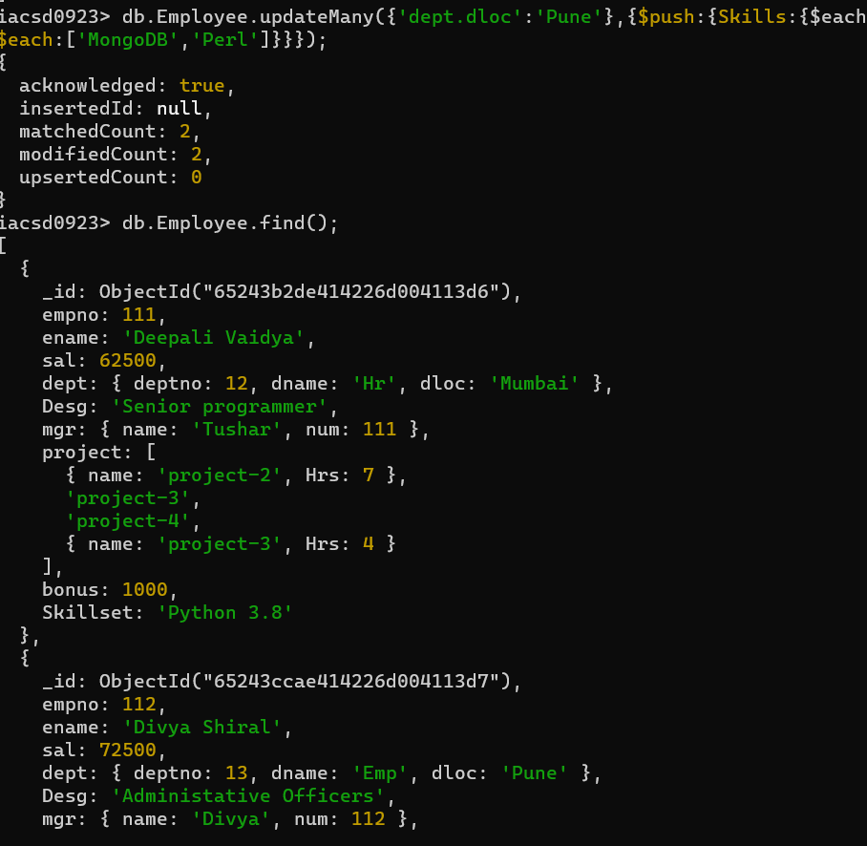

24. Delete first hobby from hobby array for all employees who are working on project-1

or project-2

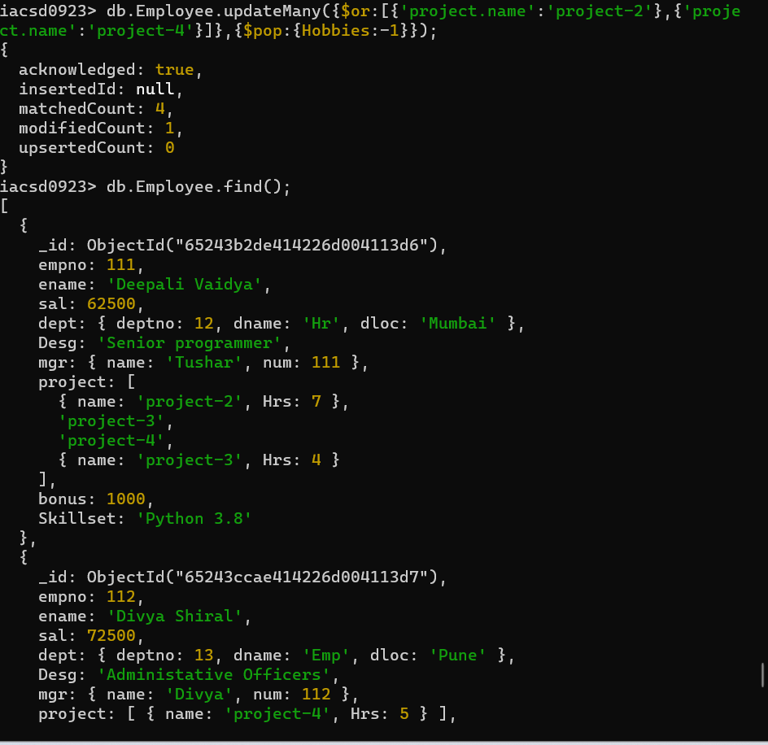

25. Delete last hobby from hobbies array for all employees who are working on project

which is at 2 nd position in projects array for 4 hrs

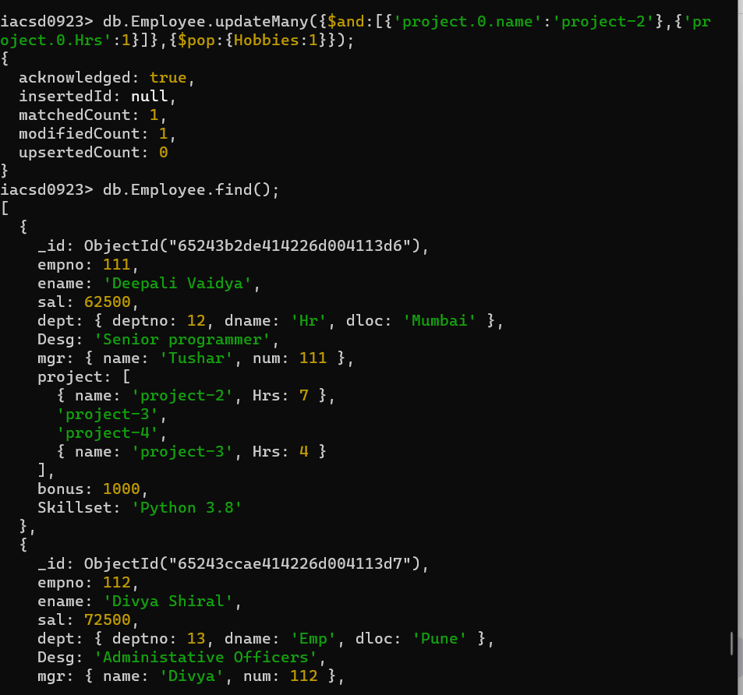

26. Add 2 new projects at the end of array for all employees whose skillset contains Perl

or python

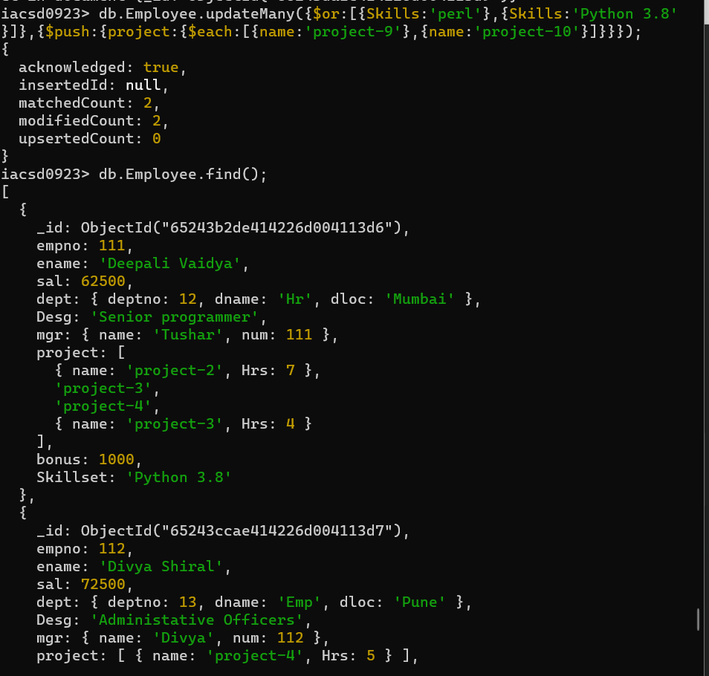

27. Change hrs to 6 for project-1 for all employees if they working on the project-1 for <

6 hrs. otherwise keep the existing value.

